**Study on Socio-economic Status of the Fishermen and Dry Fishers Communities at Ashugonj Upazila in Brahmanbaria, Bangladesh**



**A Thesis**

In partial fulfillment of the requirement for the degree of M.S in Marine Environmental Management

**Course Code: 599**

Submitted By

**Saikat Das**

|  |  |  |
| --- | --- | --- |
| Examination Roll | **:** | 17207128 |
| Registration No | **:** | 17207128 |
| Session | **:** | 2020-2021 |
| Year of Examination | **:** | 2021 |
| Examination Held in | **:** | 2024 |

Institute of Marine Sciences

University of Chittagong

Chattogram-4331, Bangladesh

**October 2024**

**Author’s Copy**

**Recommendations**

The thesis entitled “**Study on Socio-economic Status of the Fishermen and Dry Fishers Communities at Ashugonj Upazila in Brahmanbaria, Bangladesh**” is an original research work by **Saikat Das** (ID- 17207128) and it was carried out under my supervision.

I certify that the author did the dissertation work presented here and that as to style and contents; the dissertation is suitable for submission for the partial fulfillment of the requirements for the degree of B.Sc. (Hon’s) in Marine Science.

**Supervisor**

**Faiz Md Taimur**

Assistant Professor

Institute of Marine Sciences

University of Chittagong

Chattogram-4331, Bangladesh

**Director**

**Dr. Sheikh Aftab Uddin**

Professor

Institute of Marine Sciences

University of Chittagong

Chattogram-4331, Bangladesh

**Dedicated**

**To**

**My Beloved Family**

**Acknowledgment**

First and foremost, I humbly acknowledge and express my deepest gratitude to the Almighty God, the Most Compassionate and Merciful, the Supreme Ruler of the cosmos. It is with a profound sense of reverence that I attribute the completion of my academic journey, particularly in submitting my thesis for the degree of Master’s in Marine Environmental Management, to His benevolent guidance.

I feel proud to extend my deepest sense of gratitude, wholehearted indebtedness, sincere appreciation, and profound regards to my supervisor, **Faiz Md Taimur**, Assistant Professor, Institute of Marine Sciences for his unwavering support, guidance, and scholarly mentorship. His insightful feedback and commitment to academic excellence have been instrumental in shaping the direction of this research.

I would like to thank my honorable director, **Dr. Sheikh Aftab Uddin**, Professor, Institute of Marine Sciences, University of Chittagong.

I extend my sincere gratitude to the faculty members of the Institute of Marine Sciences, whose collective wisdom and commitment to academic excellence have enriched my learning experience. The scholarly environment they fostered has been a constant source of inspiration.

I am thankful to Md. Joynal Abedin, Abdul Karim Majhi, Somit Das, Milon Joldash, and the fishers’ community, fish traders, and fish dryers of the Ashuganj for providing intense support during the sampling period.

For their valuable cooperation and guidance in all aspects of this study, I will always be grateful to two special people, Saroare Shikder and Md. Orpon. The study would not be completed properly without their assistance.

Special thanks to my study partner Rubel Rana, Bijoy Debnath for assisting me during the research. Without their immense support, it would be difficult for me to complete my task.

Finally, but not least, I express my heartfelt thanks and gratitude to my beloved family for their ultimate support, motivation, and endless love throughout this journey.

The Author,

October 2024

**Table of Content**

|  |  |  |
| --- | --- | --- |
| **Chapter** | **Content** | **Page No.** |
|  | Recommendation | [ii](https://simple.wiktionary.org/wiki/ii) |
| Acknowledgement | [iv](https://simple.wiktionary.org/wiki/iv) |
| Table of Content | [vi](https://simple.wiktionary.org/w/index.php?title=vi&action=edit&redlink=1) |
| List of Figure | ix |
| Abstract | x |
| **One** | **1. Introduction** | 1-9 |
|  | * 1. Background information | 2-6 |
| * 1. Problem statement | 6-8 |
| * 1. Rationale of the study | 8-9 |
| 1.4 Objectives of the study | 9 |
| **Two** | **2. Literature review** | 10-25 |
| **Three** | **3. Materials and Methods** | 26-35 |
|  | 3.1 Research design | 27 |
| 3.2 Study area | 28 |
| 3.2.1 Geographical Location | 28 |
| 3.2.2 Climate and Environment | 29 |
| 3.3 Study Population | 29 |
| 3.3.1 Demographic Characteristics | 29 |
| 3.3.2 Socio-economic Background | 29 |
| 3.3.3 Sampling Technique | 30 |
| 3.4 Data Collection Methods | 30 |
| 3.4.1 Quantitative Data Collection | 30-31 |
| 3.4.2 Qualitative Data Collection | 31-32 |
| 3.5 Data Analysis | 33 |
| 3.5.1 Quantitative Data Analysis | 33 |
| 3.5.2 Qualitative Data Analysis | 33-34 |
| 3.6 Ethical Considerations | 34 |
| 3.6.1 Informed Consent | 34 |
| 3.6.2 Confidentiality | 34-35 |
|  | 3.6.3 Non-maleficence | 35 |
| **Four** | **4. Results** | 36-67 |
|  | 4.1 Fishermen Community | 37 |
| 4.1.1 Personal and Social Status | 38 |
| i. Age Distribution | 38 |
| ii. Marital Status | 38 |
| iii. Experience | 38 |
| iv. Educational Attainment | 38-39 |
| v. Religious Composition | 39 |
| vi. Family Structure | 39 |
| vii. Family Size | 39 |
| viii. School Enrollment of Fishermen’s Children | 39-40 |
| ix. School Dropout Rates Among Fishermen’s Children | 40 |
| x. Reasons for School Dropout | 40 |
| xi. Health Facilities Access | 40 |
| xii. Housing Conditions | 40-41 |
| xiii. Number of Children Among Fishermen | 41 |
| xiv. Sanitation Facilities | 41 |
| xv. Location of Fishermen | 41 |
| xvi. Craft Used by Fishermen | 41 |
| xvii. Fishing Gear Utilized | 41-42 |
| xviii. Fishing Off-Seasons | 42 |
| 4.1.2 Economic Status | 46 |
| i. Own Land Among Fishermen | 46 |
| ii. Total Land Ownership | 46 |
| iii. Yearly Income | 46 |
| iv. Annual Family Expenditure | 47 |
| v. Annual Cost for Children’s Education | 47 |
| vi. Annual Cost for Health and Medicine | 47 |
| vii. Annual Cost for Boat Repairs | 47-48 |
| viii. Annual Cost for Net Repairs | 48 |
| ix. Platforms for Fish Sales | 48 |
| 4.1.3 Occupational Status | 51 |
| i. Working Hours Per Day | 51 |
| ii. Occupational Satisfaction | 51 |
| iii. Alternative Livelihoods | 51 |
| iv. Role of Women | 51 |
| 4.2 Dry Fishers Community | 53 |
| 4.2.1 Personal and Social Status | 53 |
| i. Location | 53 |
| ii. Age Distribution | 53 |
| iii. Marital Status | 53 |
| iv. Experience | 54 |
| v. Education | 54 |
| vi. Religion | 54 |
| vii. Family Type | 54 |
| viii. Family Size | 54 |
| ix. Children’s School Enrollment | 55 |
| x. School Dropout Children | 55 |
| xi. Reason Behind Dropout | 55 |
| xii. Earning Members | 55-56 |
| xiii. Health Facilities | 56 |
| xiv. Housing Condition | 56 |
| 4.2.2 Economic status | 60 |
| i. Land Ownership | 60 |
| ii. Yearly Income | 60 |
| iii. Annual Costs for Preparation of Drying Place | 60 |
| iv. Fish Buying Costs | 60-61 |
| v. Annual Food Costs | 61 |
| vi. Annual Children's Education Costs | 61 |
| vii. Annual Health and Medicine Costs | 61 |
| viii. Annual Savings | 61-62 |
| ix. Selling Platforms for Dry Fish  4.2.3 Occupational status | 62 |
| i. Occupational Satisfaction | 65 |
| ii. Working Hours per Day | 65 |
| iii. Contribution of Children in Dry Fisher's Families | 65 |
| iv. Contribution of Women in Dry Fisher's Families | 65 |
| v. Common Diseases | 65-66 |
| **Five** | **5. Discussion** | 68-61 |
|  | 5.1 Socio-economic status of fishermen of Ashuganj | 69-72 |
| 5.2 Socio-economic status of fish driers of Ashuganj | 72-75 |
| 5.3 Comparison Between the Socio-economic Status of Fishermen and Dry Fishers in Ashuganj Upazila | 76 |
| 5.3.1 Personal and Social Status | 76-78 |
| 5.3.2 Economic Status | 78-80 |
| 5.3.3 Occupational Status | 80-81 |
| **Six** | **6. Conclusion** | 82-84 |
|  | 6.1 Conclusion | 82-83 |
| 6.2 Recommendations | 83-84 |
|  | **References** | 85-96 |
|  | **Appendix** |  |

**List of Figures**

|  |  |  |
| --- | --- | --- |
| **Figure No.** | **Caption** | **Page** |
| Figure 3.1 | Research design | 27 |
| Figure 3.2 | Study area map | 28 |
| Figure 4.1 | Personal and social status of fishermen (i-vi) | 43 |
| Figure 4.2 | Personal and social status of fishermen (vii-xii) | 44 |
| Figure 4.3 | Personal and social status of fishermen (xiii-xviii) | 45 |
| Figure 4.4 | Economic status of fishermen (i-vi) | 49 |
| Figure 4.5 | Economic status of fishermen (vii-ix) | 50 |
| Figure 4.6 | Occupational status of fishermen (i-iv) | 52 |
| Figure 4.7 | Personal and social status of fish driers (i-vi) | 57 |
| Figure 4.8 | Personal and social status of fish driers (vii-xii) | 58 |
| Figure 4.9 | Personal and social status of fish driers (xiii-xiv) | 59 |
| Figure 4.10 | Economic status of fish driers (i-vi) | 63 |
| Figure 4.11 | Economic status of fish driers (vii-ix) | 64 |
| Figure 4.12 | Occupational status of fish driers (i-v) | 67 |

**Abstract**

This study examines the socio-economic and occupational conditions of fishermen and dry fishers in Ashuganj Upazila, Bangladesh, through a detailed survey of 37 fishermen and 20 dry fishers. The results indicate that fishermen face significant economic hardships, with 64% being landless and 72% earning between BDT 168,000 and 217,999 annually, which is insufficient to meet the high cost of living. On average, fishermen’s family expenditures range between BDT 280,000 and 300,000 per year, leaving little room for savings or investments. The educational levels among fishermen are low, with 45% having only completed primary school, which further limits their economic mobility and ability to diversify income sources. Dry fishers, though relatively better off, also face considerable challenges. About 75% of dry fishers spend between BDT 600,000 and 1,099,999 annually on fish purchases, and the majority live in modest housing conditions, with 70% residing in tinshed houses. Despite these costs, dry fishers tend to have better economic stability, with 75% owning land, which offers them a degree of financial security and opportunities for income diversification. Educational attainment is higher among dry fishers compared to fishermen, with 25% having completed secondary education. The study recommends enhancing educational opportunities, improving access to healthcare, and offering financial support for boat and gear maintenance to help fishermen and dry fishers alleviate their economic pressures. It also suggests promoting income diversification through alternative livelihoods such as fish processing or small-scale agriculture. The implementation of these measures, along with sustainable fishing practices, could significantly improve the socio-economic conditions of both groups, ensuring their long-term livelihood security and resilience against external economic and environmental challenges. This research provides critical insights into the socio-economic dynamics of fishing communities in Ashuganj Upazila and offers actionable solutions to improve their well-being and economic stability.

**Chapter 1**

**Introduction**

* **Background Information**
* **Problem Statement**
* **Rationale of Study**
* **Objectives**

**Chapter 1**

**Introduction**

**1.1 Background Information**

Bangladesh, a country interspersed with rivers, lakes, and an extensive coastline along the Bay of Bengal, is endowed with abundant fisheries resources. Fisheries are one of the most important subsectors that play a significant role in the economy of Bangladesh in terms of socioeconomic advancement of rural fishermen and are considered to be the animal protein supply, employment, earning of foreign thrust sector for sustainable development and currency, and alleviation of poverty (Ali et al., 2020). The fisheries sector plays a vital role in the national economy, contributing significantly to food security, employment, and export earnings (Rahman et al., 2021). The Fisheries sector contributed about 4.37% to GDP, 23.37% to agriculture, 2.01% to the total foreign exchange, and provides 60% of the animal protein consumed by the people of Bangladesh (DoF, 2014). It provides full-time and part-time employment opportunities to about 5.51 million people in various dimensions such as fishing, fish trading, processing, transporting, marketing, exporting, and associated activities (DoF, 2012). More than 12 percent of the total population of Bangladesh is engaged in this sector on a full-time and part-time basis for their livelihoods (Islam et al, 2016). Now Bangladesh has become a self-sufficient fish-producing country and thereby the country supplements about 60% (with a per capita of 62.58 g/day against a targeted 60 g/day) of the daily animal protein intake of its people (DoF, 2022). The country is ranked 3rd in inland open-water capture production and 5th in world aquaculture production (FAO, 2020). Exporting fish, shrimp, and other fisheries goods brought in a lot of money for Bangladesh (Islam et al., 2021). About 98% of total fish products are exported to European countries (48.51%), USA (30.06%) and Japan (9.32%) (Hossain, 2003).

Bangladesh is a small country with an area of 1,47,610 km2 which is blessed with about 3.86 million ha of open inland waterbody, 0.84 million ha of closed inland waterbody, and marine waters covering an area of 1.18 sq. km (DOF, 2022). These water bodies are very rich in fisheries resources. The country has one of the world's largest floodplain systems, along with numerous rivers, lakes, ponds, and canals, providing ideal habitats for freshwater fish species. Major rivers such as the Padma, Jamuna, Meghna, and their tributaries are rich in fish biodiversity. Species like hilsa (Tenualosa ilisha), rui (Labeo rohita), and catla (Catla catla) are among the most economically significant. Inland fisheries in Bangladesh are composed of capture fisheries and aquaculture, where these two sectors contributed to 28.19% and 56.76% of the country’s total fisheries production respectively (Yearbook of Fisheries Statistics of Bangladesh 2018-19). According to the Department of Fisheries, inland fisheries contribute over 80% of the total fish production in Bangladesh (DoF, 2022). The marine fisheries sector of Bangladesh is equally significant, with a 710 km long coastline and an Exclusive Economic Zone (EEZ) of 118,813 km2 (Hossain et al., 2020). The Bay of Bengal hosts a variety of marine fish species, including shrimps, crabs, and other valuable finfish. Hilsa, the national fish of Bangladesh, migrates from the sea to freshwater rivers to breed, making it a crucial species for both inland and marine fisheries (Rahman et al., 2009). The marine fishing sector provided only about 15.05% of national fisheries production of 6.599 lakh MT, it involves over 200 industrial trawlers and more than 67000 artisanal vessels where artisanal small-scale fishery contributes 83.75% i.e. 5.53 lakh MT and large industrial fishery contributes 16.25% i.e. 1.07 lakh MT of total marine production. (Yearbook of Fisheries Statistics of Bangladesh 2018-19).

The country is blessed with a huge fisheries diversity including both freshwater and marine water species. There are about 795 native species of fish and shrimp in the freshwater and marine waters of Bangladesh of which 260 freshwater species, 475 marine water species, 36 marine shrimp species, 24 freshwater prawn species, and also 12 exotic species have been introduced (National fish week compendium, 2022). A total of 264 freshwater fish species under 57 families and 12 orders inhabiting the rivers, canals, haors, beels, and ponds of the country (Rahman, 2005). The present record of marine fishes comprises 426 species that are studied under 110 families in 26 orders (Hossain et al., 2020). The crustaceans include 36 shrimp species, 25 prawn species, and numerous crab species (AftabUddin et al., 2021). In addition, there are 10 species of pearl-bearing bivalves, 27 species of edible tortoise and turtle (Banglapedia, 2021), 16 species of crab, and 6 species of lobster (BdFish, 2012).

Dried fish is a significant component of traditional diets in many parts of the world, especially in coastal and riverine regions. It is one of the popular food items and is widely consumed in Bangladesh. Drying fish is one of the oldest and simplest methods of food preservation, relying on natural processes to extend the shelf life of fish while retaining its nutritional value (Suchi et al., 2022). This preservation method has been practiced for centuries and continues to be a vital part of food culture and economy in countries like Bangladesh (Kubra et al., 2020). It is the biggest fish processing activity in both value and volume in the coastal region as well as all over Bangladesh (Kubra et al., 2020). Fish drying involves reducing the moisture content in fish to about 15%-16% (Al Mehedi et al., 2020). This method is applied to fish from both marine and inland sources to produce "Shutki" (Kubra et al., 2020). The practice of drying fish in the open-air using wind and sunlight to evaporate moisture (Al Mehedi et al., 2020) dates back to ancient times (Mehtaj et al., 2018). It is the simplest and most cost-effective method for preserving fish (Jamila et al., 2009). Products made from dried fish, which can be conveniently kept, are easily marketed and shipped. (Ali et al., 2014). In Bangladesh, approximately 20% of the marine catch is used to produce dried fish throughout the year (Ahmed et al., 2007; Shamsuddoha, 2007). A significant portion of the dried fish is exported, generating a substantial amount of foreign exchange (Saha, 2003). This product is in high demand in countries like India, Malaysia, the UK, the USA, the UAE, Sri Lanka, Hong Kong, and Singapore (Jamila et al., 2009; Kubra et al., 2020). During the 2019-2020 fiscal year, Bangladesh exported 4,141.40 metric tons of dried fish, valued at 542.1 million TK (DoF, 2020).

Dried fish accounts for the 4th most significant share of fish consumed in Bangladesh and is much relished by the country’s people for its flavor, texture, and taste (Belton and Hossain, 2018). It is an accessible and low-cost food source and can contribute a large percentage of protein and significant micronutrients to the diet of poor people. Fish drying is the most extensive fish processing activity in Bangladesh that contributes significantly to livelihoods and nutrition, especially for poor and marginalized communities in coastal and inland areas. These activities are of great importance to Bangladesh, as more than 17 million people, including 1.4 million women, depend on fish farming, processing, and handling (Haque et. al, 2015). After harvesting, more than one-third of the landings are used for drying all year round; therefore, these drying practices have provided solvency to thousands of populations. As a result, dried fish has demand both on the national and international markets. In contrast, the export of dried fish has increased from 517 metric tons (value 94 million USD) in the fiscal year 2001–2002 to 3144 metric tons (value 5.01 million USD) in 2018-2019 (DoF, 2019).

Fishers and fish drier communities represent the backbone of many coastal and riverine economies worldwide. These communities, often located in regions rich in marine and freshwater resources, play a crucial role in the fishing and seafood processing industries. Their livelihoods depend on the sustainable harvest and preservation of fish, which are vital for both local consumption and international trade. Fishers, or fishermen, are individuals engaged in the capture of fish and other aquatic organisms from oceans, rivers, lakes, and other water bodies (Braga & Musiello-Fernandes, 2022). Their activities can be broadly categorized into artisanal and industrial fishing. Artisanal Fishers typically operate on a small scale using traditional methods and equipment, often working close to shorelines, and relying on small boats or even fishing from the shore (Hendriks, 2022). Artisanal fishing is a way of life that is deeply intertwined with local cultures and traditions. On the other hand, industrial fishers use larger vessels and advanced technology to harvest fish on a commercial scale and can venture further into the sea and capture larger quantities of fish, contributing significantly to the global seafood supply (Encyclopedia Britannica, Inc., 2024). Both types of fishers face challenges such as overfishing, climate change, and regulatory restrictions. Despite these challenges, fishers continue to be a vital part of the food supply chain, providing a crucial source of protein to millions of people around the world (Bene, 2006). Fish drier communities specialize in the preservation of fish through drying, a process that extends the shelf life of fish and adds value to the catch (BdFish, 2011). These communities are often located in areas with favorable climatic conditions for natural drying processes, such as coastal regions with abundant sunlight and wind. The drying process involves cleaning, salting, and laying out fish to dry in the sun or air. This traditional method is both simple and cost-effective, requiring minimal equipment and energy. Modern techniques, such as mechanical drying, have also been adopted to improve efficiency and product quality.

Both fishers and fish drier communities hold significant cultural and social importance. Fishing traditions are often passed down through generations, fostering a sense of identity and community. Festivals, rituals, and culinary practices associated with fishing and fish drying are integral to the cultural heritage of these communities. These communities face numerous challenges, including overexploitation of fish stocks, environmental degradation, and the impacts of climate change. Sustainable fishing practices and improved fish drying methods are essential to ensure the long-term viability of their livelihoods. Support from governments, NGOs, and international organizations can help these communities adapt to changing conditions and maintain their vital role in the global food system.

Ashugonj, located in the Brahmanbaria District of the Chittagong Division of Bangladesh, lies within the Meghna River delta at an altitude of 10 meters (36 feet). The town is notable for the Port of Ashuganj and its power plant, which significantly contributes to the country's electricity supply, especially for the capital city. Impressively, Ashugonj Power Station generates almost 25% of Bangladesh's electrical output. On the opposite side of Ashuganj, Zia Fertilizer Ltd manufactures chemical fertilizer for the nation. Additionally, the town boasts over 500 rice mills, producing more than 40% of the country's rice. Ashuganj serves as a crucial commercial hub, featuring a major river port and a transit line that connects to India. Moreover, it is a popular layover destination for coach buses traveling between Dhaka and Sylhet, offering accommodations such as Hotel Ujan Vati and Hotel Razmoni. According to the 2011 Bangladesh census, Ashuganj Upazila, with a total land area of 67.59 km², had 33,552 households and a population of 180,654, of which 54,449 (30.14%) were under 10 years of age, 36,749 (20.34%) lived in urban areas, a literacy rate (age 7 and over) of 51.20% compared to the national average of 51.8%, a sex ratio of 1,045 females per 1,000 males, and a population density of 2,673 people per km².

Located on the banks of the Meghna River, this region is crisscrossed by the Titas River, which flows through it and eventually merges with the Meghna, enhancing its geographical and economic significance (Banglapedia, 2024). It is an important upazila in the Brahmanbaria District characterized by one major river, 31 beels, innumerable ponds, and extensive seasonal floodplains (Mia et al., 2015). Studies on the socio-economic conditions of Meghna River fishermen revealed that 90% were Hindus and 10% were Muslims; overall, only 2.5% had secondary-level literacy, 45% could sign their names, 75% and 80% lived in katcha houses, 7.5% and 2.5% in half-building houses, with poor sanitary conditions evidenced by 50% using katcha toilets in study area 1 and 47.5% in study area 2, where family sizes ranged from 2-11 persons, and the highest annual income bracket (Tk 100,000-200,000) included 52.5% of fishermen, while the lowest income bracket (Tk 25,000-50,000) included 5% (Mia et al., 2015). Another study suggested that almost 300 villagers participated in collecting and processing various types of fish from October to March each season in a single village of Ashuganj, named Charlalpur, and earned 100 crore taka annually (The Business Standard, 2024).

**1.2 Problem Statement**

The socio-economic status of fishermen and dry fishers in Ashugonj Upazila, Brahmanbaria, Bangladesh, represents a critical yet underexplored facet of local livelihood dynamics and economic sustainability. Situated within the broader context of Bangladesh's coastal communities, these groups play a pivotal role in both local subsistence and regional trade. However, despite their significant contribution to the local economy, there exists a noticeable gap in comprehensive understanding regarding their socio-economic conditions, challenges, and opportunities.

Firstly, income instability looms large over the lives of fishermen and dry fishers. Fluctuating fish prices, influenced by market dynamics and seasonal variations in catch, render their incomes unpredictable and often insufficient to meet basic needs. This instability exacerbates poverty and economic vulnerability within these communities, perpetuating cycles of deprivation and limiting opportunities for financial growth and investment in alternative livelihoods. Access to resources poses another formidable challenge. Unequal distribution of fishing grounds, coupled with inadequate infrastructure such as storage facilities and transportation networks, hinders productivity and market access. Moreover, limited access to credit and financial services constrains their ability to invest in equipment upgrades, technology adoption, and diversification of income sources. These constraints not only stifle economic progress but also perpetuate dependency on exploitative credit terms and middlemen within the supply chain. Health and safety concerns further compound the challenges faced by fishermen and dry fishers.

The nature of their work exposes them to various occupational hazards, including physical injuries, exposure to harsh weather conditions, and health risks associated with handling fish and operating fishing equipment. Inadequate access to healthcare facilities and preventative measures exacerbates these risks, compromising their overall well-being and productivity. Educational disparities also emerge as a significant barrier to socio-economic mobility within these communities. Limited access to quality education perpetuates intergenerational poverty, restricting opportunities for youth to pursue alternative livelihoods and break free from the cycle of subsistence fishing. This lack of educational opportunities not only limits individual potential but also undermines community development efforts aimed at enhancing human capital and fostering socio-economic resilience. Environmental pressures further threaten the sustainability of their livelihoods. Rapid urbanization, industrial pollution, and unsustainable fishing practices degrade local ecosystems, diminishing fish stocks and disrupting traditional fishing patterns. Climate change-induced shifts in weather patterns and sea levels pose additional challenges, exacerbating the vulnerability of these communities to natural disasters and environmental degradation.

The livelihoods of fishermen and dry fishers are intricately tied to the natural resources of Ashugonj Upazila, particularly its riverine and coastal ecosystems. These communities rely heavily on fishing and drying processes as primary sources of income, sustaining not only their own households but also contributing to the supply chain of local markets and beyond. Their socio-economic well-being is influenced by numerous factors, including access to fishing grounds, market dynamics, environmental changes, governmental policies, and socio-cultural practices. At present, empirical studies focusing specifically on the socio-economic status of these communities in Ashugonj Upazila remain scarce. Existing literature often provides fragmented insights, lacking in-depth analyses that could inform targeted interventions and policy formulation aimed at enhancing their livelihood security and overall quality of life. Key aspects such as income variability, access to credit and markets, health conditions, educational opportunities, and social integration are crucial yet under-researched dimensions that warrant thorough investigation. Understanding these dynamics is not merely academic but holds profound implications for sustainable development and poverty alleviation efforts in coastal regions of Bangladesh. By elucidating the socio-economic realities faced by fishermen and dry fishers, this study seeks to contribute to a more nuanced understanding of their needs, vulnerabilities, and aspirations. Such insights are indispensable for devising contextually appropriate strategies that promote economic resilience, social equity, and environmental sustainability within Ashugonj Upazila and similar coastal communities nationwide.

**1.3 Rationale of the Study**

The study of the socio-economic status of fishermen and dry fishers in Ashugonj Upazila, Brahmanbaria, Bangladesh, is crucial for several reasons. Firstly, these communities play a vital role in the local economy, contributing significantly to both subsistence and commercial fishing activities. Despite their economic importance, there is a lack of comprehensive research focusing specifically on their socio-economic conditions, challenges, and opportunities. Understanding the socio-economic dynamics of these communities is essential for identifying and addressing the barriers they face. Issues such as income instability, limited access to resources and markets, health risks associated with fishing activities, educational disparities, and environmental pressures significantly impact their livelihoods and overall well-being.

By conducting this study, we aim to fill existing knowledge gaps and provide empirical insights that can inform evidence-based policies, interventions, and community development initiatives. This research seeks to contribute towards enhancing the resilience of fishermen and dry fishers, promoting sustainable livelihood practices, and improving their socio-economic outcomes. Furthermore, this study is timely given the rapid socio-economic changes and environmental challenges affecting coastal communities in Bangladesh. It seeks to highlight the complexities of livelihoods dependent on fisheries, offering pathways for inclusive growth and equitable development within Ashugonj Upazila and similar coastal regions.

In summary, the socio-economic status of fishermen and dry fishers in Ashugonj Upazila reflects a complex interplay of economic, social, environmental, and institutional factors. Addressing these multifaceted challenges requires a nuanced understanding of their root causes and impacts on community livelihoods. By investigating these issues comprehensively, this research endeavors to fill the existing knowledge gap by conducting a comprehensive inquiry into the socio-economic status of fishermen and dry fishers in Ashugonj Upazila. Through rigorous data collection, analysis, and interpretation, this study aims to provide actionable insights that can inform policy interventions, community development initiatives, and advocacy efforts aimed at improving the livelihoods and socio-economic conditions of these vital yet often marginalized groups.

**1.4 Objectives of the Study**

The main objectives of this study are:

1. To assess the income levels, educational attainment, and occupational patterns of fishermen and dry fishers in Ashugonj Upazila.
2. To analyze the impact of environmental and market dynamics on their economic activities.
3. To identify the socio-cultural and institutional factors affecting their livelihoods.
4. To suggest policy recommendations for improving the socio-economic status of these communities.

**Chapter 2**

**Literature Review**

**Chapter 2**

**Literature Review**

Alam and Yousuf (2024) examined the socio-economic challenges of fishermen in the Karnaphuli, Jalkhadar, and Meghna River regions of Bangladesh, revealing a shift from traditional fishing due to declining fish stocks and market control by brokers. Conducted with 100 respondents, it found that rising living costs and inadequate social services contributed to declining incomes. The majority of respondents were male and part of nuclear families. The study emphasized the need for government and NGO support to improve education, health, and social facilities, as well as better enforcement of fishing regulations to enhance livelihoods.

Kamal et al. (2023) examined the socio-economic conditions of small-scale dry fish producers in Nazirartek, Cox's Bazar, Bangladesh, highlighting stark disparities between dry fishers and wholesalers. Dry fishers faced low incomes, poor literacy rates, inadequate living standards, and malnutrition, with incomes between 81,000 and 100,000 BDT annually. In contrast, wholesalers enjoyed better conditions, earning over 100,000 BDT annually and having higher education levels. The study identified key challenges such as vulnerability to extreme weather, low wages, reliance on loans, and lack of training and technological support. It suggested that improved management, marketing, and national cooperation could enhance the dry fishing industry’s potential.

Barua et al. (2022) assessed the socio-economic conditions of fishermen near Kaptai Lake in Rangamati district, finding moderate literacy rates among tribal fishermen, with 15% illiterate and only 6% having higher secondary education. Annual incomes ranged from Tk. 24,000 to Tk. 38,400, and housing was often inadequate, with 49% living in bamboo homes. Many faced poor sanitation and limited access to clean drinking water, alongside challenges like extortion and lack of fishing gear. Overall, the socio-economic status of these tribal fishermen was similar to that of other traditional fishing communities in Bangladesh.

Swathi & Vandana (2022) assessed 100 families in Sasihithlu village using a structured questionnaire to gather data on demographics, education, occupations, and living conditions. The average age of respondents was 38 years, with family sizes typically having four or more members. Fishing was the primary occupation for 55.6% of the population, while others were involved in business, salaried jobs, agriculture, and various other activities. Income distribution showed that 79.2% of fishermen earned less than Rs. 10,000 per month, with only a small percentage earning between Rs. 50,000 and 1,00,000.

Ubarhande and Ghonge (2022) examined the socio-economic conditions of fishermen in Deulgaon Raja, Buldhana District, where the fish market was disorganized and unhygienic, and fishermen lived below the poverty line. Annual incomes were under 3 lakhs, and families relied entirely on fishing as their primary income source. Education levels were generally low, with 40% having secondary education and only 10% having higher education. The effectiveness of cooperative societies and NGOs in improving conditions was limited. The study aimed to create a database of fishermen’s socio-economic status and proposed solutions to improve their situation.

Hussain et al. (2021) examined the socioeconomic conditions of fishermen in Kanaighat, Sylhet, based on data from 50 randomly selected individuals. Approximately 55% were exclusively engaged in fishing, with income levels varying significantly. Educational attainment was low, with many fishermen lacking formal education. While most had access to sanitary facilities and tube well water, they faced challenges such as illiteracy and insufficient government support. The study highlighted reliance on local suppliers for fishing equipment and a limited range of income-generating activities outside of fishing.

Rahman et al. (2021) assessed the socio-economic conditions of the fishermen community near Chalan Beel in Faridpur Upazila, Pabna District, Bangladesh. Data collected from various sources revealed that most fishermen (40%) were aged 31-45 and predominantly Muslim (68%). The community had high illiteracy rates (70%) and suffered from common diseases like gastritis and diarrhea. While housing varied, all fishermen had access to electricity, tube-well water, and mobile phones. Despite some modern amenities, their livelihoods remained vulnerable due to illiteracy, low income, and climate change impacts. The study suggested that government and NGOs should improve education, financial support, and infrastructure to enhance their socio-economic status.

Halim (2021) examined the socio-economic and livelihood conditions of fish farmers in Kotalipara upazila, Gopalganj, Bangladesh, based on a survey conducted from July to December 2020. The survey revealed that the average age of farmers was 40.5 years with 17.5 years of experience, and most were married. Housing conditions were mostly kacha with inadequate sanitation facilities. The majority practiced polyculture fish farming and relied on various sources for fries. While 25% report significant economic improvement, 55% see marginal social gains, and 20% experience no change. The study suggested that enhancing floodplain management with better technology could further improve their socio-economic status.

Uddin et al. (2020) assessed the socio-economic conditions and livelihood structures of fishermen in Muradnagar Upazila, Cumilla, from February to July 2019. The majority of fishermen were Hindu, with a minority being Muslim, and 70% were directly involved in fishing. Literacy was low at 18%, and most lived in tin shed houses. They relied on tube-well water for drinking and seek medical treatment based on their economic status, with poorer fishermen visiting village doctors and wealthier one’s going to hospitals. The fishermen were involved in additional activities like net making and agriculture. The study highlighted the need for better training, improved loan access, and government intervention to enhance their livelihoods and addressed their challenges.

Ahamed et al. (2020) examined the socio-economic conditions and livelihoods of fishermen in an area with a near-equal distribution of Muslims and Hindus. Educational levels were low, with 66% being illiterate or only able to sign. The majority were young (21-30 years old) and lived in poor conditions, with 80% in kacha houses and many lacking basic sanitation and electricity. Most fishermen relied heavily on fishing, with a low off-farm income ratio indicating their dependency on the beels. Approximately 61% were in the lower class, reflecting widespread poverty. The study suggested improving both private and public sector support and motivating fishermen to ensure sustainable use of water bodies.

Kubra et al. (2020) conducted from July to November 2017, examined dried fish producers in Patuakhali and Barisal, identifying 17 fish species for sun drying. Challenges included inadequate storage, lack of capital, and middlemen involvement. Most producers, predominantly Muslim and from joint families, saw socio-economic improvements through dried fish marketing, with Barisal producers faring better than those in Kuakata.

Tint and Aye (2020) conducted the socio-economic and livelihood assessment of 161 artisanal fisher folks from 23 villages around Mein Ma Hla Wildlife Sanctuary over seven months from July 2016 to January 2017. The main businesses included finfish fisheries, shellfish fisheries, eel trapping, and fish buying. The demographic study revealed that 78% were male and 22% were female, with the largest age group being 25-35 years old. Education levels were low, with 37% having primary education and only 8% having reached high school. The highest income earners were fish buyers, while eel trappers had the lowest income. Notably, 70% of fishing boats were non-motorized and the catch per day varied by season.

Yadav et al. (2020) assessed the socio-economic status of fishers in Ratnagiri, Maharashtra, using interviews with 64 randomly selected fishermen. It found that the majority of fishers were middle-aged men, married, and living in joint families. Most fishers were educated, lived in pacca houses, and had bank accounts, but many families had only one income earner and limited daily expenditure. The study suggested that attending training programs and exploring alternative livelihoods could improve their income and overall socioeconomic condition.

Rahman et al. (2021) examined the livelihood and socio-economic conditions of the fishermen community near Chalan Beel in Bangladesh, based on data collected from July to December 2020. Key findings showed high illiteracy (70%) and prevalent health issues, with housing conditions varying widely. Despite access to electricity and clean water, challenges like low income and climate change threatened their livelihoods, perpetuating poverty. The study called for government and NGO initiatives to improve education, financial support, and infrastructure.

Ahamed et al. (2020) highlighted the poor socio-economic conditions of fishermen in the area, with a nearly equal division between Muslims and Hindus. Most were young, with high illiteracy rates (65.96%) and inadequate housing and sanitation facilities. A significant dependency on fishing was evident, as 60.6% were classified as lower class. Limited livelihood options and the need for collaborative support from both private and public sectors were crucial for sustainable improvement.

Siam et al. (2020) examined the socio-economic conditions of fishers on Nijhum Dwip, Bangladesh, highlighting that 94% of fishers were male and predominantly Muslim. The majority were married, with a notable dropout rate among school-going children. Most households lived in katcha dwellings without electricity. Fishers used various nets and motorboats, averaging a catch of 35-80 kg per day, with monthly incomes around BDT 7,000-8,000. The research suggested that government and NGOs should improve educational and financial support to enhance the community's livelihood.

Rishan and Fagun (2019) examined the socio-economic and livelihood conditions of fishermen in Habiganj Sadar Upazila, Bangladesh, revealing a predominantly Muslim community aged 31-40, mostly married and living in larger families. A significant portion was illiterate, with annual incomes primarily between 65,000 BDT and 80,000 BDT. Access to health services and sanitation was limited, though many had electricity. The findings emphasized the need for better education, technical training, and employment opportunities to improve their socio-economic status.

Mamun et al. (2020) assessed the livelihood of 30 shrimp farmers in Shyamnagar upazila, Satkhira district, Bangladesh, focusing on the impact of progressive shrimp farming. It found that 56.67% of farmers depended solely on shrimp farming, with annual incomes ranging from 50,000 to 20,00,000 BDT. The practice of extensive shrimp farming had significantly improved their living conditions, including better housing, drinking water, electricity, sanitation, and medical facilities. Farmers had also increased spending on education and health, while reducing expenses on cattle, indicating a strong reliance on shrimp farming for their livelihoods.

Sunny et al. (2019) evaluated the livelihood status of hilsa fishers along the Padma River in Bangladesh, using interviews and Focus Group Discussions from July to October 2018. Key livelihood activities included fishing, fish drying, trading, net mending, boat making, agriculture, small business, and daily labor. Among the 288 households surveyed, most fishers (39%) were aged 31-40, with annual incomes ranging from 32,000 to 48,000 BDT, and 10% earning over 100,000 BDT. The study found that hilsa fishers faced significant social and economic challenges such as overpopulation of fishers, low income, lack of alternative income sources, and conflicted with stakeholders. Improving their livelihood required effective initiatives and proper implementation.

Belton et al. (2018) examined the role of dried fish in the diets and livelihoods across Africa and Asia, with a focus on Bangladesh, where a significant portion of fish was processed by drying. It highlighted that dried fish production was often overlooked in fisheries research, which tended to focus on fishers rather than those involved in the mid- and downstream segments of the value chain. Using social wellbeing as an analytical framework, the chapter explored the material and subjective conditions of laborers in fish drying, presenting case studies from three sites with diverse labor conditions. These case studies revealed how various social relations and institutions affected the wellbeing of laborers, often resulting in negative outcomes and exploitation despite the critical role of dried fish in the industry.

Kulkarni et al. (2018) stated that the study on fishermen in Udgir, Latur district, highlighted their poor socio-economic conditions, characterized by low income and inadequate access to basic amenities. Most lack ownership of homes or land, leading to financial instability. Recommendations included leasing land to fishermen, offering subsidized loans for fish ponds, and providing training and health insurance to enhance their livelihoods and living standards.

Billah et al. (2018) assessed the socio-economic conditions of fishermen in the Bhatiary coastal area of Chittagong, Bangladesh, based on interviews with 100 respondents conducted from January to June 2009. The findings revealed that the majority of fishermen were middle-aged males, predominantly Muslim, with limited education—78% had only completed primary school. Most lived in nuclear families, with 80% owning their homes. Secondary occupations included small-scale businesses and agriculture, and many facing challenges such as insufficient credit and lack of equipment. Additionally, a significant portion of children were not receiving education, highlighting socio-economic struggles in the community.

Sufian et al. (2017) assessed the livelihood of 40 fishers in Dekar haor, Sunamganj, Bangladesh. The study found that annual incomes ranged from BDT 34,900 to 176,100, with a mean income of BDT 60,566.67. Most fishers (72.5%) had low incomes and were seeking alternative professions. The community was predominantly middle-aged (31-45 years), Muslim, and had an average family size of 6.875. Education levels were low, with 57% illiteracy among fishers. Housing and sanitation were underdeveloped, and health services were mainly provided by village doctors. Women contributed to income-generating activities. The study suggested community-based aquatic resource management to improve fishers' livelihoods.

Salim et al. (2017) evaluated literacy, health, income, and livelihood security of fisher households in Kerala, using data from 567 households collected over a year in 2011. It found that most fishermen were aged 36-55 and had high literacy rates. The marine capture sector not only yielded the highest income but also had significant debt levels. Income from non-fishery activities such as labor and business were notable, yet households often spended most of their income on food and relied on private money lenders due to debt. The study offered insights for developing targeted plans to improve the conditions of the fishing community in Kerala.

Bhendarkar et al. (2017) investigated the socio-economic conditions of fishermen in two reservoirs, Saroda and Chhirapani, in Kabirdham district, Chhattisgarh. With 1.64 lakh hectares of water available for fish culture, effective management was crucial for improving the welfare of poor fishermen. The survey of 83 cooperative members revealed that most fishermen were aged 31-40, had larger families, and a significant portion was illiterate. Housing conditions were predominantly katcha, and incomes varied widely, with landless fishermen earning significantly below the poverty line. The study suggested that enhancing fish culture could improve their socio-economic status.

Wirda et al. (2017) explored the economic potential and human resources of coastal communities in Serdang Bedagai Regency, focusing on Pantai Sialang Buah Desa Teluk Mengkudu. Using descriptive analysis of randomly sampled data, it found that while the coastal area had significant economic potential in fisheries, seagrass cultivation, beach tourism, crop production, and breeding, the socio-economic conditions remain underdeveloped. The study highlighted insufficient government and private sector involvement, particularly in infrastructure development, as a barrier to realizing this potential.

Karuppusamy and Karthikeyan (2017) assessed the socio-economic and cultural conditions of fishermen in Puducherry Region, interviewing 200 respondents. It found that most fishermen are Hindu, aged 41-45, and possessed only primary education, with incomes ranging from Rs. 5,000 to Rs. 20,000 per month. Despite their low income, many used modern mobile phones and home appliances, though 62% were addicted to liquor, consuming over 30% of their income. Key challenges included issues with fish sales, price fixing, and market access. Fishermen seek government support for short-term loans, improved transportation, and the establishment of more fish markets and processing units.

Navy et al. (2016) examined the fish trade sector in Cambodia, highlighting key studies on the socioeconomic value of fish in the region. It critically analyzed the design and methodology of three major studies, pointing out their weaknesses and pitfalls. The review aimed to draw lessons that could guide the development of better approaches for assessing the socio-economic impacts of fisheries resources in the Mekong Basin.

Trina et al. (2016) assessed the socioeconomic status of fishers from April to December 2014. Findings showed that most fishers were young, primarily engaged in fishing, and had low educational levels, with a significant portion living in inadequate housing and lacking sanitary facilities. Health services were minimally utilized, and annual incomes were generally low. Key recommendations included improving education, health, sanitation, and access to government loans to enhance their socioeconomic conditions.

Ahsan et al. (2016) assessed the socio-economic conditions of fishermen and intermediaries in Coxs Bazar, Bangladesh, revealing widespread illiteracy and inadequate living standards. About 35% of respondents were illiterate, and many lived in poor-quality housing, with average incomes between Tk. 400-500. Key challenges included poor infrastructure, lack of credit and training, and an excess of intermediaries. The study suggested the need for institutional support and improved services to enhance the fish marketing system sustainably.

Bhuyan and Islam (2016) assessed the livelihood status of the traditional fishing community along the Meghna River near Narsingdi District from September 2015 to March 2016, surveying 100 fishermen. Key findings revealed that most fishermen were Hindu, aged 24-45, and largely illiterate, relying on village doctors for medical care. Many lived in poorly constructed homes and faced financial challenges, often taking loans from local groups. Statistical analyses showed significant relationships between fishing income and various socio-economic factors, including contentment, education, and access to services.

Ghosh et al. (2016) examined the socio-economic and livelihood profiles of 300 fishers in the Sundarbans region, revealing that 67% were middle-aged, with 78.33% primarily engaged in agriculture and 76% in fishing as a secondary occupation. Most respondents had an annual income between Rs. 50,000 and 1 lakh, indicating a middle-income status. The findings also showed intermediate education levels, active participation in training programs, and improved access to sanitation facilities, highlighting ongoing development efforts in the community.

Shill et al. (2016) examined the socio-economic conditions of fishermen in Bhagyakul and Mandra, revealing that the majority were aged 31-50 and predominantly Hindu. Educational levels were low, with 14% illiterate, and housing conditions were poor, as most lived in mud houses. Healthcare access was limited, primarily relying on local practitioners, and sanitation facilities were inadequate. Annual incomes ranged from BDT 66,000 to 105,000, with many fishermen obtaining loans from NGOs for fishing equipment.

Baki et al. (2015) examined the livelihood status of the traditional fishing community near the Turag and Buriganga Rivers from January to June 2013, involving 50 household heads. Most fishermen were aged 31 to 40, with 66% being illiterate and only 6% having secondary education. Health services were primarily accessed from village doctors, and sanitation facilities were inadequate, with 44% using basic toilets and 22% lacking sanitary options. Key challenges included high illiteracy rates and river pollution.

Hossain et al. (2015) evaluated the livelihood status of the fishing community along the Punorvaba River in Dinajpur Sadar Upazila from January to August 2013. Most fishermen were aged 36-45, predominantly Muslim, with family sizes of 5-7 members. Over 45% engaged primarily in fishing, but 50% were illiterate. Healthcare access varied, with many relying on village doctors. To address declining fish stocks, fishermen suggested management strategies like prohibiting brood fish capture and establishing fish sanctuaries.

Reza et al. (2015) examined the socio-economic conditions of fishermen along the Atrai and Kankra rivers in Chirirbandar Upazila, Dinajpur from October 2013 to January 2014. It involved 25 randomly selected fishermen heavily dependent on fishing, using various participatory tools for data collection. Findings indicated that most fishermen were middle-aged, landless or marginal landholders, predominantly Muslim, and engaged in fishing as their primary occupation. They faced challenges like riverbed siltation, declining fish stocks, financial constraints, and inadequate training, with only a minority managing to improve their livelihoods through fishing.

Sharif et al. (2015) conducted the study in Pitambarpur, Bangladesh, from September to December 2014, surveyed 45 farmers through interviews and observations. It revealed that most farmers lived in semi-pucca houses, with a majority being over 40 years old. Financing sources were predominantly banks (73%), and nearly all farmers used tube well water. The area had low literacy rates (90% illiterate), with healthcare reliance on quack doctors (95%). Most farmers' income stems from fish farming, and the community was primarily Muslim, with a preference for nuclear family structures. Mobile phone usage was nearly universal among the farmers.

Mahmud et al. (2015) evaluated the livelihood status of fishermen along the Paira River from April to October 2012. It found that most fishermen were aged 21 to 40, with a predominance of medium-sized and joint families. Fishing was the primary occupation for over 86%, but many fishermen had low educational levels and limited health service access. The average monthly income from fishing was around 5000 BDT. Major challenges included illiteracy, lack of scientific knowledge, and insufficient government support, suggesting that targeted interventions could improve their overall livelihood conditions.

Das et al. (2014) conducted that the survey in Beel Dakatia assessed the consequences of water logging on fisheries and the adaptability of local communities. Finding indicated that the majority of respondents were young and predominantly Muslim, with high school attendance. Many lived at nuclear families and faced economic challenges, relying on local resources for water and healthcare. The study called for government and development partner support through training and credit facilities to enhance sustainable fish and prawn farming livelihoods.

Ismail (2014) stated that Fishing was a major industry in Visakhapatnam District, Andhra Pradesh, contributing significantly to India's fishing product exports. The district accounted for a substantial portion of the state's export value, with around 14 lakh people in Andhra Pradesh dependent on fishing, and 25% of them residing in Visakhapatnam. Each fishing boat supported the livelihood of over 50 families, and there were 118 primary fishermen co-operative societies and 2,800 mechanized boats in the area. Visakhapatnam coast was renowned as a central hub for fishing activities.

Bappa et al. (2014) assessed the socio-economic status of fishermen in Marjat Baor, Jhenidah district, interviewing 50 families. Most respondents were married, aged 30-45, and primarily Hindu. The community faced significant challenges, including high illiteracy (60%) and inadequate housing, with only 18% having electricity. Fishing was the main occupation for 60%, but they struggled with health issues due to contaminated water and often sought treatment from quacks. The majority had low annual incomes, highlighting the need for educational and credit support to improve their living conditions.

Paul et al. (2013) assessed the livelihood status of the fishing community in the Turag River area of Bangladesh. It found that most fishermen were aged 35-40 in Birulia and 40-45 in Boroibari, primarily consisting of Hindus and largely illiterate. In Birulia, all fishermen received loans from microcredit NGOs, while those in Boroibari benefited from management programs like IPAC. Approximately 63% of fishermen in Birulia and 35% in Boroibari had moderate annual incomes (30,000-60,000 tk), while 33% in Birulia and 65% in Boroibari reported high incomes (above 60,000 tk). Notably, there was no government support for the fishing community in either area.

Nayak and Mishra (2008) stated that Ganjam district, with a 60 km coastline, was rich in aquatic resources and supported 37,715 people across 27 villages, primarily dependent on fishing. The community included two main types of fishermen: Kaibarta and Nolia. Educational levels were low, with 57.8% illiterate, 21.5% having primary education, and 15.9% reaching upper-primary. Annual incomes ranged from Rs. 18,000 to 20,000. Marine fishermen focused on capture fishery, while inland fishermen engaged in both culture and capture fishery. Support was provided by the Orissa Fishermen Cooperative Society, which supplies nets and boats, and the National Cooperative Development Corporation (NCDC), which offered financial assistance.

Hossain (2008) reported that just 14% and 16% of the respondents, who were residents of coastal communities, had completed their elementary and secondary school, respectively, and that the majority of respondents (60%) were illiterate. For each respondent, the annual household income was calculated using his money gathered during the year from commerce, farming, fishing, and salt production, etc. Most individuals (58% and 35%, respectively) were classified as having low and medium incomes. It was just 5% of the population with a high income.

Rabbani (2007) reported that 76.67% of fisherman lived in kacha, 8.33% in semi-pacca buildings, and the other 37% in pacca buildings. Additionally, the study revealed that 45% of fisherman relied on their village doctor for medical care, whilst 11.67% and 3.33% of fishermen went to the Upazila Health Complex and MBBS doctors, respectively, for their medical needs. Just 6.67% of fisherman reported having a Pacca toilet.

Faruque (2006) studied the Fishermen's socioeconomic position in Borobela Beel. Muslims made up 80% of the fishermen, followed by Hindus (12.5%), and others (7.5%). Fishing families had an average of 6.3 family members. There were severe problems with the fishermen's health, hygiene, and housing. For the most part, the fisherman created their own mud homes (82.5%) and toilets (67.5). The fishermen's average monthly salary ranged from BDT 2350 to BDT 3250, depending on their particular circumstances.

Islam (2005) reported that the average pond size was 0.16 ha (40 decimals), with a range of 0.40 ha (11 decimals) to 0.81 ha (200 decimals), based on a survey on the socioeconomic level of fish farmers in some chosen regions of the Dinajpur district. Sixty-four percent of the study's ponds were perennial, and sixty-six percent of farmers had a single pond; only 24 percent owned numerous ponds. It revealed that the fry stocking period spanned from March to May, with an average stocking density of 17,370 fry/ha/year. At a rate of 1,976 kg/ha/year and 371 kg/ha/year, respectively, rice bran and mustard oil cake were often utilized as fish culture feed. The average annual usage of TSP, urea, and organic fertilizer—primarily cow dung—was 294 kg/ha and 3,242 kg/ha, respectively. In the research region, the average yearly fish output was determined to be 2,609 kg/ha/year. He concluded that the primary issues facing pond fish farming were a lack of scientific understanding, a scarcity of fry, high production costs, diseases, a lack of funding, inadequate extension services, and bad financing facilities.

Rokanuzzaman (2004) assessed that the majority of fisherman (42.3%) were in the young age group, with 21.1% and 36.6% of them being in the middle and elderly age groups, respectively. The respondents were divided into three groups based on the size of their families: small families (2-4 members), medium families (5–6 members), and large families (>6 members).

Rahman (2003) investigated the socioeconomic standing of Jamuna River fishermen. The percentage of Muslims and Hindus among the fisherman was 92.5% and 7.5%, respectively. The age group of 30 to 40 years old was found to be the largest (67.5%), while the age group of less than 30 years old was the least (17.5%). There were 5.68 people in each family on average. Among the fisherman, 52.5% of people were illiterate, 22.5% were semiliterate (can write their name), and 15% had received up to elementary level, 7.5% to secondary level, and 2.5% to S.S.C. level of education was note.

Shahjahan et al. (2003) conducted research on the socioeconomic status of Jamuna River fishermen. He discussed the socioeconomic conditions of riverine fisherman with regard to income, family size and makeup, education level, and religion. According to his findings, Muslims made up the vast majority (66.67%), whereas Hindus made up a somewhat smaller percentage (33.37%). The ber jal fishermen had the biggest family size (7, 87 members), while the contemporary jal had the smallest family size (5.25 members). In terms of education, 31.67% of riverine fisherman had completed primary school, 5.0% had only completed high school, and 66.33% of fishermen were illiterate. The bulk of the fishermen were illiterate overall. The ber jal fishermen's highest average monthly revenue was discovered. He concluded that ber jal fisherman were more productive than fishermen using other equipment.

Rahman et al. (2002) explored the socio-economic challenges faced by the fishermen of Bhatipara village in Mymensingh, Bangladesh. The fishermen, from the low-caste Barman community, were marginalized and disadvantaged, primarily engaging in group fishing with seine nets. Income distribution was highly unequal, with significant disparities between marginal and non-marginal households. Opportunities for women were limited due to social constraints. The fishermen lacked access to formal banking and support services, relying on exploitative usury transactions. The study suggested that introducing cage aquaculture and providing technical and social support could improve their livelihoods and boost fish production.

Hossain (2001) reported on the educational attainment of riverine fishermen, 65% lacked literacy, 30% had completed primary school, and 5% had only completed secondary school.

Quddus et al. (2000) discovered that while there were no illiterate fish farmers in Dhaka, the educational levels of pond farmers were below SSC at 43%, below bachelor at 38%, and above bachelor at 19%.

Mannu (1999) examined the socioeconomic circumstances of seafaring fishermen in Kuakata and found that 92% of them were married, 96% of them were in the 18–40 age range, 72% of them were full-time fishermen, 20% had a secondary occupation, 36% owned their own home, 16% had crop land, including a house, ranging from 30 decimal to 5 acres, 28% lived in Khas land outside the dam, 12% lived jointly with their father, 89% earned an average of 25, 000 taka annually, 14% earned from other sources, 88% saw fishing as beneficial, 8% said they were living hand to mouth, 4% of them fished during the winter and rainy season, and 3% claimed to be debtors rather than surplus earners.

Ahmed (1999) investigated the socioeconomic circumstances of coastal fisherman, during the fry-catching season, 73.33% of fishermen reported having a daily revenue of more than TK.50, whereas 26.67% of fishermen reported having a daily income of less than TK.50. Their homes were primarily made of mud and a particular type of weed leaf known locally as "golpata." They were made up of 68.33% Muslims and 31.67% Hindus, with a family size of 6.4 and 70% of the fishermen being under 40. Additionally, 75% of the fishermen were illiterate and less than 5% of the fishermen visited the village doctor. Because there were no tube wells, most fishers used pond water.

According to Ahmed (1999), who also looked into the socioeconomic circumstances of coastal fisherman, 73.33% of them made less than Taka 50 a day.

Roy and Dorairaj (1998) carried out a socioeconomic survey of the fishing community in 10 South Andaman fishing localities, 4 Middle Andaman fishing localities, and 3 North Andaman fishing localities. Every locality had an average family size ranging from four to six members. With an average of 45.3%, the literacy rate in South Andaman ranged from 19.85 to 66.07%. 61.91% of nearly literate people had completed elementary school. In RRO Camp Ranga and Rangat Bay, the male literacy rates in the Middle Andaman were 27.81% and 28.92%, respectively. Localities differed in when they had fishing. In the height of the fishing season, fish landings in the South, Middle, and North Andaman ranged from the lowest monthly amount of Rs. 816–1225 at Choudari to Rs. 7,866–10,200 at Panighat in the South Andaman. The mean monthly expenses per household varied across several localities, ranging from Rs. 845 to Rs. 2800.

Tsai and Ali (1997) stated that the amounts of fish available was contingent upon the time of year, the quantity of fishermen fishing, and their style of fishing. Anglers employed a variety of fishing equipment and crafts when fishing. Seasons, flooding conditions, target species, and species sizes all affected the sorts of fishing gear that are employed. With a few exceptions, most fishing gear types were designed to accommodate many species, rather than a single target species. In most cases, the fishermen employed every kind of fishing equipment available, from simple hand tools to highly advanced seine and gill nets, to capture fish. Different places might have different names for the same piece of fishing equipment. Some were named for the target fish species. Additionally, fisherman used fishing craft based on availability and capability.

Ahmed (1996) discovered that 84% of the people living in the Tangail District were full-time fishermen; 24% worked as a secondary vocation; 81% of the people there fished all year round; and 92% of the people were members of various associations, clubs, and cooperatives.

Charles et al. (1994) highlighted the importance of understanding both economic and human factors in fisheries, emphasized the need for interdisciplinary approaches in fishery socio-economics. It covered a range of topics including management goals, income distribution, community structure, and decision-making. Despite its significance, the literature on fishery socio-economics was often scattered and hard to access. This report compiled and assessed the state of research in developing fisheries and aquaculture, featuring regional assessments for Africa, Latin America, and Asia/Pacific, and included an extensive annotated bibliography with over 1,100 references.

Bhaumik and Saha (1994) evaluated the socioeconomic circumstances of the fishermen fishing in a few Sundarbans estuaries. The sampled fishermen's ages ranged from 20 to 70 years old. The majority of them were from the scheduled caste group, and 36.6% had between 21 and 30 years of fishing experience. They used dinghies, which ranged in size from 7.92 to 9.14 meters. The majority of them (41.5%) used beg nets for operations. Of them, 24.0% fished for 241–260 days, and 39.6% fished for 12 hours every day. Each month, 29.0% of them caught between 131 and 150 kg of fish on average. Of them, 23.4% worked in the off-season as net makers, repairers, or menderers, earning between Rs. 501 and Rs. 600 a month; 36.4% earned between Rs. 801 and Rs. 900 during the season.

DoF (1990) carried out a survey on the socioeconomic circumstances of the fishermen in eleven Upazilas of the District of Patuakhail and Barguna as part of a fisheries extension development project. The survey found that the literacy rate among fishing communities was significantly lower than that of other areas, and that their financial situation was often so poor that they were unable to pay for their children's schooling. There were many fishing houses without any kind of lavatory. The majority of fishermen were landless, and over 708 percent of them worked as laborers, repairing boats and other gear. The average daily revenue of the fishermen was TK 2025 for about 70% of them and TK 2540 for the remaining 30%.

**Chapter 3**

**Materials and Methods**

* **Research Design**
* **Study Area Map**
* **Study Population**
* **Data Collection Methods**
* **Data Analysis**
* **Ethical Considerations**

**Chapter 3**

**Materials and Methods**

**3.1 Research Design**

The current study aims to determine the socio-economic status of the fishermen and dry fishers’ communities at Ashugonj upazila. For the fulfillment of this purpose, the following plan and procedures were followed, as illustrated in Figure 3.1.

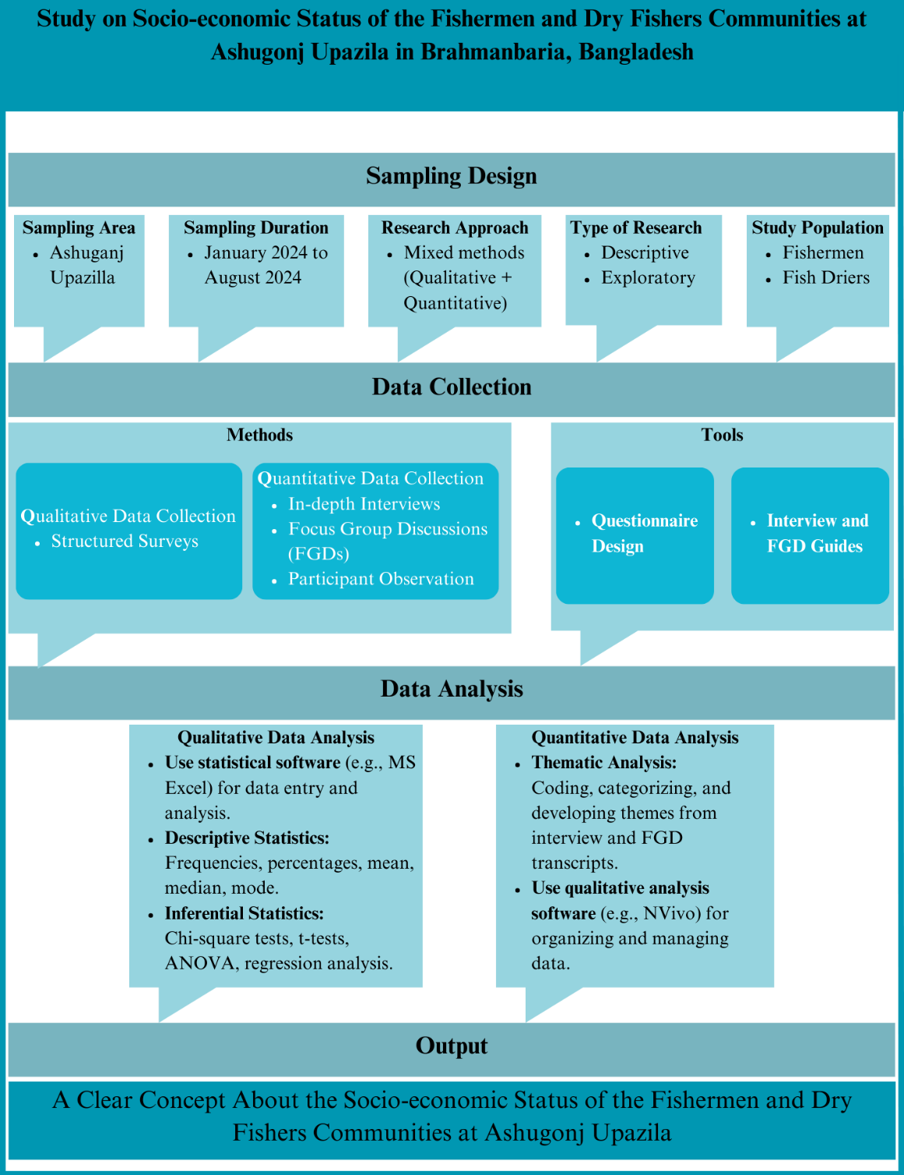

**Figure 3.1** Research design about the socio-economic status of the fishermen and dry fishers’ communities at Asuganj Upazila

**3.2 Study Area**

**3.2.1 Geographical Location**

Ashugonj Upazila is situated in the Brahmanbaria District of Bangladesh. It lies along the eastern bank of the Meghna River, one of the major rivers in Bangladesh. The Upazila covers an area of approximately 67.59 square kilometers and is characterized by a predominantly rural landscape. The geographical coordinates of Ashugonj are approximately 24.0333° N latitude and 91.1500° E longitude. The following figure 3.2 shows the area selected for this research.

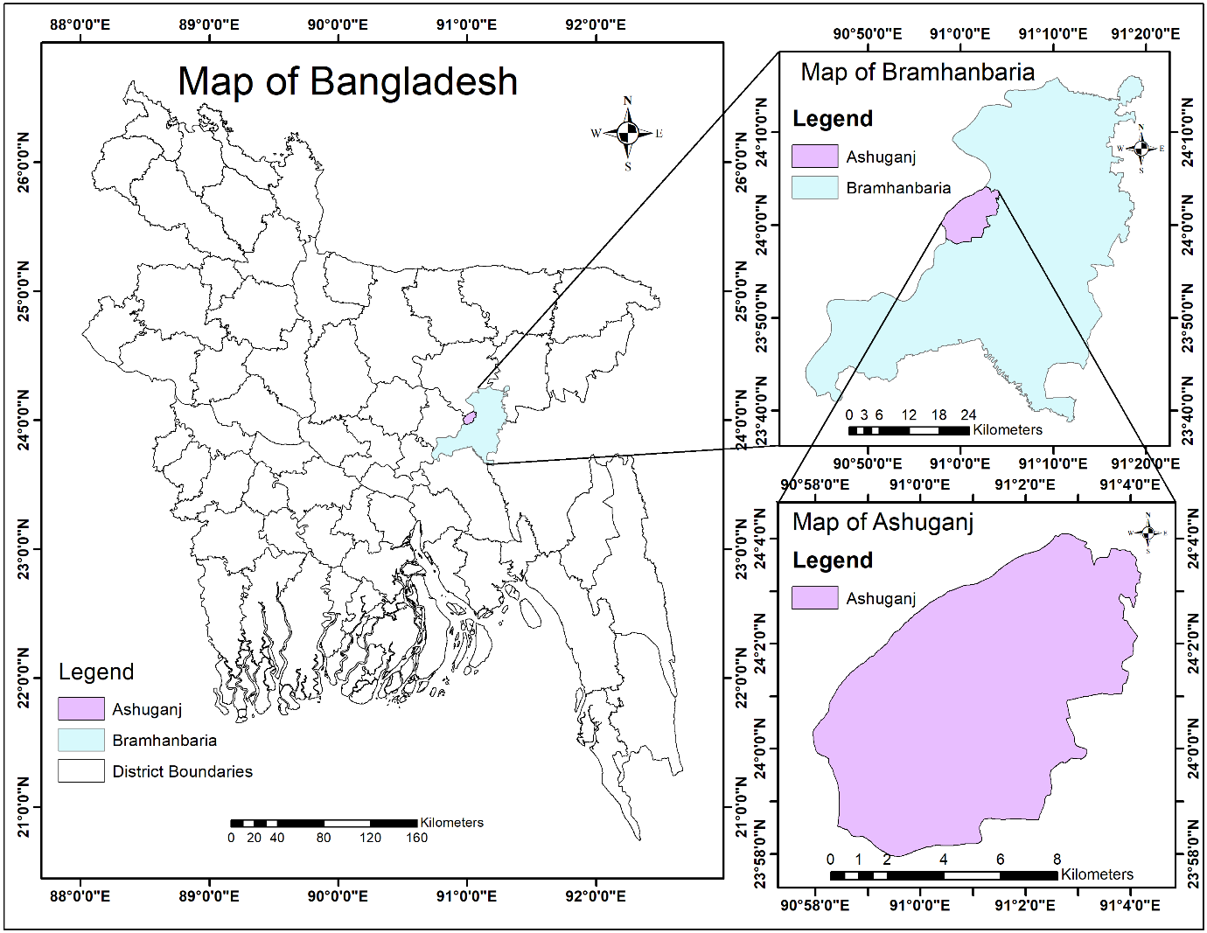

**Figure 3.2** Study area map showing Bangladesh, Bramhanbaria, and Ashuganj

**3.2.2 Climate and Environment**

The climate of Ashugonj Upazila is typically tropical, with distinct wet and dry seasons. The monsoon season, which lasts from June to October, brings heavy rainfall and occasional flooding, significantly influencing fishing activities. The dry season, from November to April, sees reduced water levels in the Meghna River, affecting fish availability.

The Meghna River is a vital natural resource for the local communities, providing both sustenance and economic opportunities. The river's ecosystem supports a diverse range of fish species, making it a crucial site for fishing activities. The environmental conditions, such as water quality and river flow, are critical determinants of the productivity and sustainability of fisheries in the region.

**3.3 Study Population**

**3.3.1 Demographic Characteristics**

The study population comprises fishermen and dry fishers residing in various villages within Ashugonj Upazila. The demographic characteristics of the study population include:

* Age: Participants range from 18 years to over 60 years, with a focus on those actively engaged in fishing and related activities.
* Gender: Both male and female participants are included, although fishing is predominantly a male-dominated occupation in the region.
* Education: The educational attainment of participants varies, with many having primary or no formal education.
* Family Size: Household sizes range from small nuclear families to extended families with multiple generations living together.

**3.3.2 Socio-economic Background**

The socio-economic background of the study population is diverse, encompassing various income levels and occupational patterns. Fishing and dry fish processing are the primary sources of livelihood, supplemented by other activities such as agriculture, livestock rearing, and small-scale trading. The economic status of these communities is influenced by factors such as access to fishing resources, market prices, and seasonal variations in fish catch.

**3.3.3 Sampling Technique**

**i. Multi-stage Sampling**

A multi-stage sampling technique was employed to ensure a representative sample of the study population. This approach involved several stages of selection to capture the diversity and complexity of fishing communities in Ashugonj Upazila.

**Stage 1: Selection of Villages**

In the first stage, a purposive sampling method was used to select villages known for their fishing activities. This selection was based on information from local authorities, including the Upazila Fisheries Office, and key informants who are knowledgeable about the local fishing industry. A total of ten villages were chosen to provide a comprehensive representation of the fishing communities in Ashugonj Upazila.

**Stage 2: Selection of Households**

In the second stage, a random sampling method was employed to select households within each chosen village. Household lists were obtained from local administrative offices, and a random number generator was used to select households from these lists. This ensured that each household had an equal chance of being included in the study, minimizing selection bias.

**Stage 3: Selection of Respondents**

In the final stage, one respondent from each selected household was chosen for the survey. The criteria for selecting respondents included being actively engaged in fishing or dry fish processing and being knowledgeable about the household’s economic activities. If multiple eligible respondents were present in a household, the individual most involved in fishing activities was selected to provide detailed and accurate information.

**3.4 Data Collection Methods**

To achieve a comprehensive understanding of the socio-economic status of fishermen and dry fishers, a combination of quantitative and qualitative data collection methods was employed.

**3.4.1 Quantitative Data Collection**

**Structured Surveys**

Structured questionnaires were used to collect quantitative data from the selected respondents. The questionnaire was designed to capture a wide range of information relevant to the study's objectives. Key sections of the questionnaire included:

* **Demographic Information:** Age, gender, education level, family size, and household composition.
* **Economic Activities:** Types of fishing activities (e.g., river fishing, dry fish processing), income sources, average monthly income, expenses, and savings.
* **Access to Resources:** Ownership of fishing gear and equipment, access to credit and financial services, and membership in fishing cooperatives or associations.
* **Health and Social Services:** Access to healthcare facilities, prevalence of occupational injuries and diseases, access to education and sanitation services, and participation in social welfare programs.

The structured survey provided quantifiable data that could be analyzed statistically to identify patterns and correlations. To ensure the reliability and validity of the questionnaire, it was pre-tested in a pilot study involving a small sample of respondents from a neighboring area. Feedback from the pilot study was used to refine the questionnaire, addressing any ambiguities or inconsistencies.

**Survey Administration**

The surveys were administered face-to-face by trained enumerators who were familiar with the local language and cultural context. Enumerators received training on the purpose of the study, ethical considerations, and techniques for administering the questionnaire. Data collection took place over a period of three months, ensuring adequate time to reach all selected respondents and address any logistical challenges.

**3.4.2 Qualitative Data Collection**

**In-depth Interviews**

Semi-structured interviews were conducted with key informants to gain deeper insights into the socio-economic dynamics of fishing communities. Key informants included village leaders, experienced fishermen, representatives from local fishing associations, and officials from the Upazila Fisheries Office. The interview guide included open-ended questions covering topics such as:

* Traditional fishing practices and cultural significance of fishing.
* Changes in fishing patterns and productivity over time.
* Challenges faced by fishermen and dry fishers, including environmental, economic, and social factors.
* Coping strategies and community resilience in the face of adversity.
* Perspectives on policy and regulatory frameworks affecting the fishing industry.

Interviews were conducted in a conversational manner, allowing respondents to share their experiences and perspectives freely. Each interview lasted between 45 minutes to one hour and was recorded with the respondent's consent for accurate transcription and analysis.

**Focus Group Discussions (FGDs)**

Focus group discussions were organized to facilitate group interactions and capture a range of perspectives on common issues faced by fishermen and dry fishers. Each FGD comprised 8-10 participants who were purposively selected to represent different sub-groups within the community (e.g., river fishermen, dry fish processors, and women involved in fishing-related activities). The FGD guide included prompts and questions on:

* Community organization and social networks.
* Collective challenges and community solutions.
* Gender roles and participation in fishing activities.
* Access to markets and economic opportunities.
* Perceptions of government and non-governmental support programs.

FGDs were moderated by a trained facilitator who guided the discussion, encouraged participation from all members, and ensured that the conversation remained focused on the topics of interest. Notes were taken during the discussions, and sessions were recorded for detailed analysis.

**Participant Observation**

Field observations were conducted to gain an immersive understanding of the daily activities and living conditions of fishermen and dry fishers. Observations focused on:

* Fishing practices and techniques used by the community.
* Dry fish processing methods and facilities.
* Interactions within the community and social dynamics.
* Living conditions, including housing, sanitation, and access to basic amenities.

Detailed field notes were taken during observations, capturing both descriptive and reflective elements. Photographs were also taken (with permission) to document key aspects of the fishing activities and community life.

**3.5 Data Analysis**

Data analysis was carried out using both quantitative and qualitative techniques to provide a comprehensive understanding of the socio-economic status of the study population.

**3.5.1 Quantitative Data Analysis**

Quantitative data from the surveys were entered into a statistical software program, such as MS Excel, for analysis. The data analysis process included the following steps:

**Data Cleaning and Preparation**

Data cleaning involved checking for missing values, outliers, and inconsistencies in the survey responses. Missing values were addressed through imputation techniques or by excluding incomplete responses from the analysis. Outliers were examined to determine if they represented valid extreme cases or errors in data entry.

**Descriptive Statistics**

Descriptive statistics were calculated to summarize the data and provide an overview of the socio-economic characteristics of the study population. Key descriptive statistics included:

* **Frequencies and Percentages:** For categorical variables such as gender, education level, and access to resources.
* **Measures of Central Tendency:** Mean, median, and mode for continuous variables such as income and family size.
* **Measures of Dispersion:** Standard deviation and range to assess the variability in the data.

**3.5.2 Qualitative Data Analysis**

Qualitative data from interviews, FGDs, and participant observations were transcribed and analyzed using thematic analysis. The qualitative data analysis process included the following steps:

**Data Familiarization**

The first step involved reading and re-reading the transcripts to become thoroughly familiar with the data. Initial notes and impressions were recorded to capture emerging themes and patterns.

**Coding**

Data were coded systematically by identifying and labeling segments of text that represented relevant themes or concepts. Coding was conducted manually.

**Categorizing**

Coded data were grouped into broader categories based on similarities and relationships between themes. For example, codes related to economic challenges were categorized under a broader theme of "economic vulnerability."

**Thematizing**

Overarching themes were developed to capture the main insights from the data. Themes were refined iteratively through a process of constant comparison and validation, ensuring that they accurately represented the data and provided meaningful insights.

**Interpretation**

The final step involved interpreting the themes in the context of the study objectives and theoretical framework. This included linking the qualitative findings to the quantitative results, highlighting complementarities and discrepancies, and drawing conclusions about the socio-economic status of fishermen and dry fishers.

**3.6 Ethical Considerations**

The study adhered to ethical guidelines to ensure the rights and well-being of participants were protected throughout the research process.

**3.6.1 Informed Consent**

Informed consent was obtained from all participants prior to their involvement in the study. The consent process included the following steps:

* **Information Provision:** Participants were provided with detailed information about the study's purpose, procedures, potential risks, and benefits. This information was presented in a language and format that was easily understandable.
* **Voluntary Participation:** Participants were informed that their participation was voluntary and that they could withdraw from the study at any time without any penalty.
* **Consent Documentation:** Written consent was obtained from participants who agreed to take part in the study. For participants who were illiterate, verbal consent was documented, and a witness was present to confirm the consent process.

**3.6.2 Confidentiality**

Confidentiality of participants' information was maintained throughout the study. Measures to ensure confidentiality included:

* **Anonymization:** Personal identifiers were removed from the data, and unique codes were used instead of names.
* **Reporting:** Findings were reported in aggregate form, and no identifying information was included in the final report or publications.

**3.6.3 Non-maleficence**

The study was designed to ensure that no harm came to participants as a result of their participation. Specific measures included:

* **Sensitive Topics:** Sensitive questions were handled with care, and participants were given the option to skip questions they were uncomfortable answering.
* **Support Services:** Information about available support services was provided to participants who experienced distress during the study.

**Chapter 4**

**Results**

* **Socio-economic status of fishermen**
* **Socio-economic status of fish driers**

**Chapter 4**

**Result**

The study, conducted over a 12-month period using a questionnaire survey involving 40 fishermen and 28 dry fishers from Ashuganj Upazila, provides a comprehensive overview of the socio-economic conditions of these two critical groups. The data highlights key differences and similarities in terms of land ownership, income levels, family structures, education, healthcare access, and occupational challenges. The fishermen community is characterized by significant economic vulnerability, with 64% lacking land ownership, which limits opportunities for income diversification and leaves them heavily reliant on fishing. Their incomes are generally low, with the majority earning between BDT 168,000 and 217,999 annually, resulting in financial strain and limited savings. Long working hours and unpredictable income due to seasonal fishing further exacerbate their hardships. Moreover, their high expenditure on family needs, education, and healthcare compounds these issues, leaving many unable to break the cycle of poverty. In contrast, dry fishers exhibit relatively better economic stability, with 75% owning land. Their incomes are notably higher, with 80% earning between BDT 900,000 and 1,899,999 annually. Despite significant costs related to drying place preparation and fish purchases, dry fishers manage to save more and maintain a higher degree of financial security. Family involvement in the drying process is common, with children and women playing active roles, contributing to household income. However, dry fishers also face long working hours, health challenges, and reliance on a single income earner, similar to fishermen. The study’s findings underscore the need for targeted interventions, such as improved access to healthcare, educational support, and alternative income opportunities, to address the socio-economic disparities between these two communities.

* 1. **Fishermen Community**

A total of 37 fishermen were surveyed in this study. Various personal, social, and economic data were collected during the survey. Personal data included age, education level, and family size. Social data focused on aspects such as marital status, household roles, and community involvement. Economic data encompassed income levels, land ownership, fishing equipment costs, and expenditure on health, education, and household needs. These data provide a comprehensive overview of the socio-economic status of the fishermen surveyed.

**4.1.1 Personal and Social Status**

[**i**](https://simple.wiktionary.org/wiki/i). **Age Distribution**

Fishermen span a broad age range, with the majority (32%) being between 24 and 28 years old. This indicates a relatively young workforce, with only a small proportion aged above 39 years. Notably, those between 29 and 33 years make up only 5.4%. The lower representation of older age groups could indicate that fishing is a physically demanding job, leading to fewer older individuals continuing in the profession. Younger fishermen might bring vitality and adaptability, but the absence of older, experienced individuals could mean a loss of accumulated traditional knowledge. The following Figure 4.1 (i) shows the age distribution of the fishermen.

**ii. Marital Status Among Fishermen**

The data shows that 73% of fishermen are married, while 27% are single. This high percentage of married individuals indicates a significant proportion of fishermen have family responsibilities. The implications of being married can range from increased economic pressure to support dependents to having greater stability through family support. This data suggests that policies aimed at improving the livelihoods of fishermen should consider the socio-economic burdens of family life. The following Figure 4.1 (ii) shows the marital status among fishermen.

**iii. Experience Among Fishermen**

The majority of fishermen have considerable experience, particularly those with 15-19 years and 30-35 years of experience, both at 8%. There are fewer less-experienced fishermen, indicating that the profession is largely filled with veterans who have dedicated their lives to fishing. This experience likely enhances their skill set, but the low entry rate (indicated by the low percentage of those with 0-9 years) suggests that the profession may not be attracting younger entrants due to its hardships or the availability of other opportunities. The following Figure 4.1 (iii) shows the experience among fishermen.

**iv. Educational Attainment Among Fishermen**

The education level among fishermen is notably low, with 54% having only completed primary education, and 24% having no formal education at all. Very few have completed secondary education (SSC), representing just 8%. This lack of educational attainment could be a barrier to economic mobility, limiting their ability to pursue alternative livelihoods, manage fishing technologies, or access financial resources. Furthermore, low education could affect their awareness and implementation of sustainable fishing practices, potentially contributing to environmental degradation. The following Figure 4.1 (iv) shows the educational attainment among fishermen.

**v. Religious Composition of Fishermen**

The fishermen’s community is predominantly Hindu (68%), with Muslims constituting 32%. This religious composition could reflect the local demographic structure or specific social and cultural associations with fishing as a profession. It may also influence community dynamics, traditional practices, and access to religious-based support networks. The following Figure 4.1 (v) shows the religious composition of fishermen.

**vi. Family Structure of Fishermen**

A majority of fishermen belong to nuclear families about 70% (26 households), while a smaller proportion remaining 30% (11 households) live in joint families. Nuclear families may suggest a trend toward smaller family units and more individualized household management, which could influence economic decisions and dependency ratios. Smaller family units might mean fewer people to support, but also fewer income-earning members, potentially placing a greater financial burden on the fisherman as the primary earner. The following Figure 4.1 (vi) shows the family structure of fishermen.

**vii. Family Size Among Fishermen**

Family size varies among fishermen, with the most common family sizes being 2-3 members (8%). Some families, however, are considerably larger, with a few consisting of 10 or more members (5%). The Larger family sizes can impose a greater economic burden on fishermen, particularly in households with multiple dependents and few earning members. This, in turn, can lead to increased pressure to overfish or work longer hours to sustain the family. The following Figure (vii) shows the family size among fishermen.

**viii. School Enrollment of Fishermen’s Children**

37% of fishermen's children are not enrolled in school, while only 24% have one child enrolled, and fewer households have multiple children in school. This low rate of school enrollment may reflect the economic constraints faced by fishermen, where children might be expected to contribute to household income instead of attending school. The lack of education for children could perpetuate the cycle of poverty in fishing communities, as they grow up with limited opportunities to pursue higher-paying jobs outside of the fishing industry. The following Figure 4.2 (viii) shows the school enrollment of fishermen’s children.

**ix. School Dropout Rates Among Fishermen’s Children**

72% of fishermen's children do not drop out of school, while 28% experience dropouts. The dropout rate, though not overwhelming, is significant enough to warrant concern. Factors such as financial hardship, a lack of value placed on formal education, or the need for children to work may contribute to this. Addressing the dropout issue could involve providing financial aid or educational incentives targeted at fishing communities. The following Figure 4.2 (ix) shows the school dropout rates among fishermen’s children.

**x. Reasons for School Dropout**

The most common reasons for children dropping out of school include family issues (3%) and financial crises (3%), followed by the need to work (21%). Financial constraints are clearly the major driver behind dropout rates. These findings suggest that initiatives aimed at reducing school dropout should prioritize addressing the economic challenges of fishing families, such as through educational scholarships or child labor alternatives. The following Figure 4.2 (x) shows the reasons for school dropouts.

**xi. Health Facilities Access**

Only 3% of fishermen access healthcare through doctors, with others relying on pharmacies (70%) and union health complexes (27%). This limited access to formal healthcare facilities suggests a need for improved healthcare infrastructure in fishing communities. Fishermen's reliance on pharmacies might indicate self-medication, which could lead to mismanagement of health conditions, while the low usage of union health complexes may reflect issues of availability or trust in such services. The following Figure 4.2 (xi) shows the health facilities of fishermen.

**xii. Housing Conditions**

Fishermen's housing conditions reveal that 3% live in roofshed brick buildings, 6% in semi-paka houses, and 91% in tinshed structures. The predominance of semi-permanent structures points to modest living conditions, which could be susceptible to environmental threats such as storms or flooding. Improvements in housing could help improve their quality of life and reduce vulnerability to natural disasters. The following Figure 4.2 (xii) shows the housing conditions for fishermen.

**xiii. Number of Children Among Fishermen**

The number of children per fisherman varies, with 2 children being the most common (27%), followed by 1 child (29%). This suggests a preference for smaller family sizes, possibly driven by economic pressures, as larger families would require greater resources for schooling, healthcare, and sustenance. The following Figure 4.3 (xiii) shows the total number of children among fishermen.

**xiv. Sanitation Facilities**

The majority (78%) of fishermen use sanitary latrines, with 22% practicing open defecation. The lack of access to proper sanitation facilities is a critical health concern. Poor sanitation can contribute to the spread of disease, which would further strain the limited healthcare resources available to these communities. The following Figure 4.3 (xiv) shows the sanitation facilities among fishermen.

**xv. Location of Fishermen**

Fishermen are concentrated in three primary areas: Hossainpur (27%), Kandapara (27%), and Paschimpara (46%). This distribution reflects key fishing hubs within the region, potentially indicating areas of greater economic activity or dependence on fishing as the main livelihood. The following Figure 4.3 (xv) shows the location of fishermen.

**xvi. Craft Used by Fishermen**

Mechanized boats are used by 72% of fishermen, while 28% use non-mechanized boats. The high use of mechanized boats suggests an inclination towards modern fishing methods, which may increase fishing efficiency but also lead to higher operational costs. The use of non-mechanized boats by a smaller percentage may indicate either traditional practices or lower-income fishermen who cannot afford mechanized alternatives. The following Figure 4.3 (xvi) shows the crafts used by fishermen.

**xvii. Fishing Gear Utilized**

Fishing gear varies across the community, with Ber Jal (37%) being the most commonly used. Other gear types like Jagat Jal (27%) and Tanajal (3%) are also used, depending on the type of fish targeted and local environmental conditions. The variety of gear suggests adaptability and specialization within the fishing community, but may also reflect varying levels of financial investment in equipment. The following Figure 4.3 (xvii) shows the fishing gears utilized by fishermen.

**xviii. Fishing Off-Seasons**

The majority of fishermen face an off-season in winter (78%), with a smaller percentage in summer (22%). These seasonal fluctuations highlight the instability in income that fishermen face, which could lead to financial strain during the non-fishing months. Seasonal unemployment programs or alternative livelihoods could help mitigate these effects. The following Figure 4.3 (xviii) shows the fishing off-seasons among fishermen.

**Figure 4.1** Personal and social status of fishermen (i-vi)

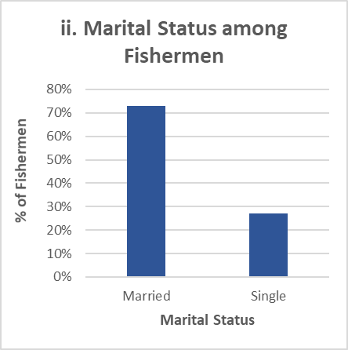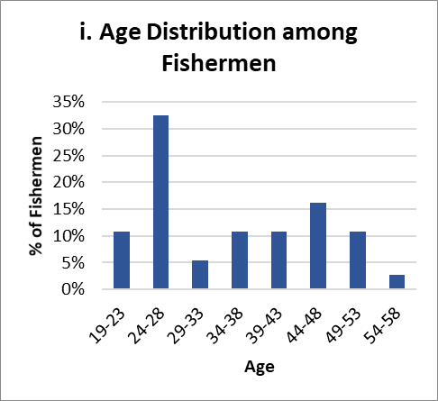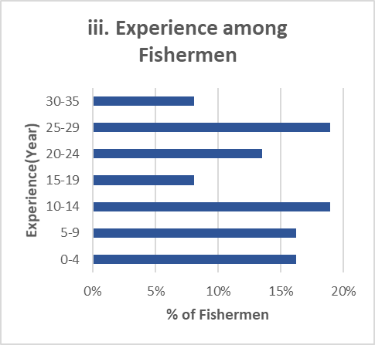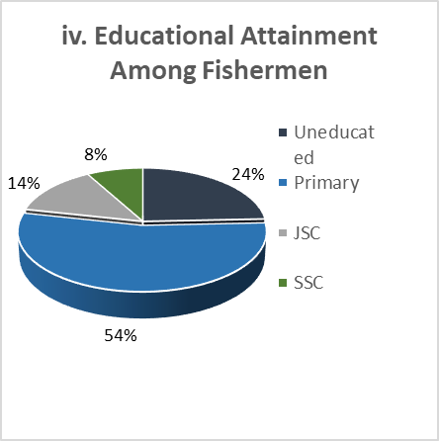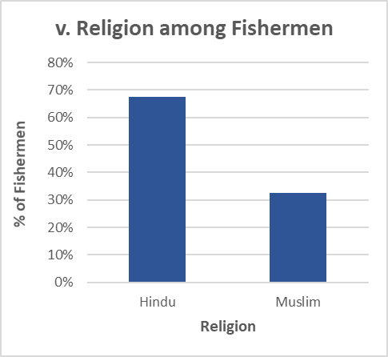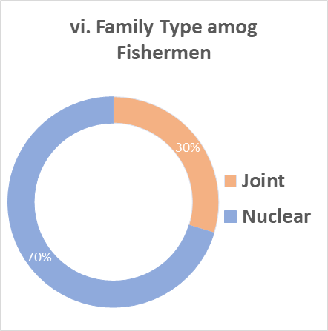

**Figure 4.2** Personal and social status of fishermen (vii-xii)

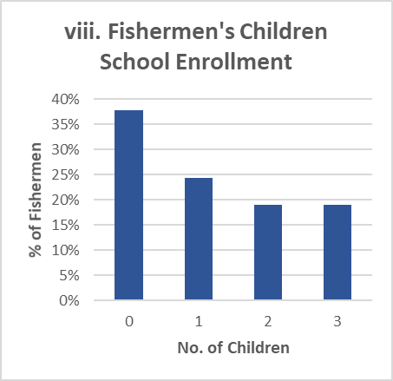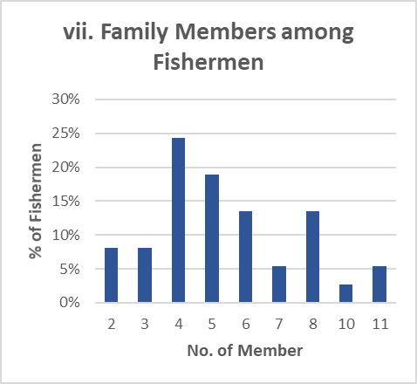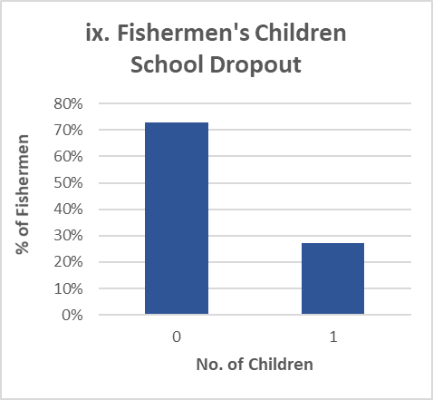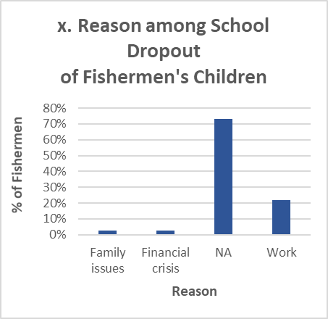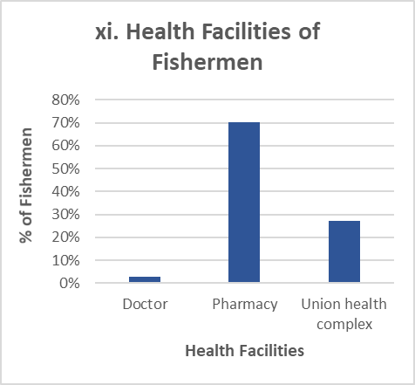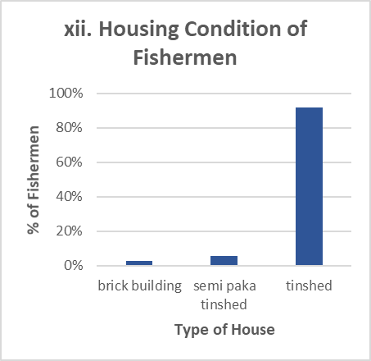

**Figure 4.3** Personal and social status of fishermen (xiii-xviii)

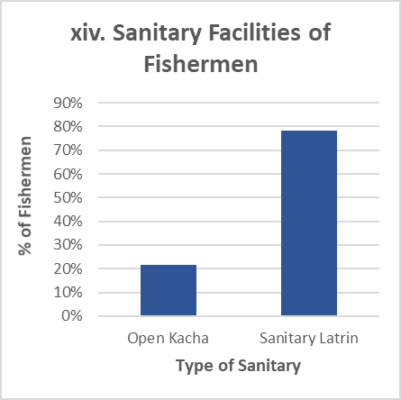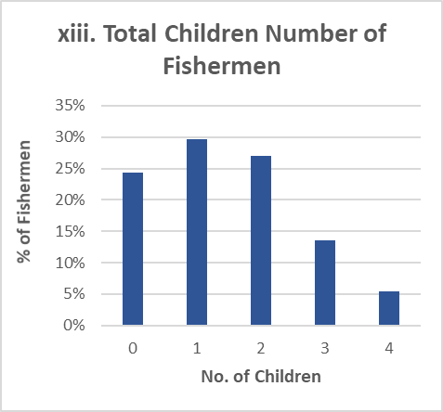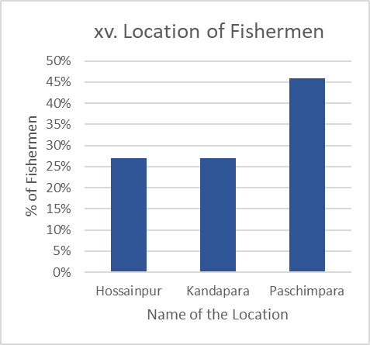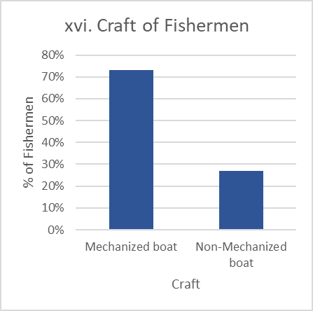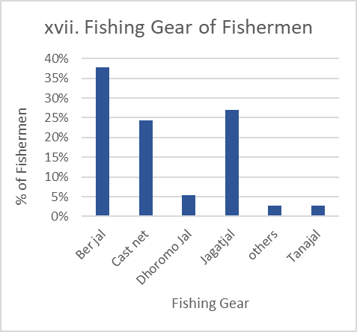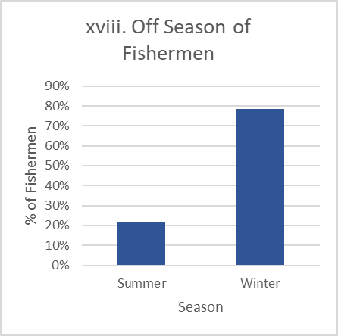

**4.1.2 Economic Status**

**i. Own Land Among Fishermen**

When examining land ownership further, 64% of fishermen do not possess any land, with only 36% owning property. The high percentage of landless fishermen underlines the precarious economic situation faced by most in the community. Land ownership often correlates with wealth and financial security, and the absence of this asset limits opportunities for income diversification. Fishermen without land must rely exclusively on fishing for their survival, making them more vulnerable to economic and environmental shocks, such as bad fishing seasons, government-imposed fishing bans, or adverse weather conditions. The following Figure 4.4 (i) shows the landowners among fishermen.

**ii. Total Land Ownership Among Fishermen**

A significant portion of the fishermen (64%) do not own any land, while 36% are landowners. For those who own land, the plot sizes range from small parcels, with 5% of fishermen owning 0.2, 0.25, and 0.3 acres each. This data highlights the economic vulnerability of the fishermen, as land ownership often serves as a critical asset for financial stability and diversification of income. The lack of land ownership forces many fishermen to rely entirely on fishing, increasing their exposure to the risks associated with seasonal fluctuations in fish availability and the instability of fish markets. Owning small plots of land may offer some supplementary income, such as through agriculture, but the majority remain heavily dependent on fishing as their sole livelihood. The following Figure 4.4 (ii) shows the land ownership among fishermen.

**iii. Yearly Income of Fishermen**

The income distribution data indicates that 72% of fishermen earn between BDT 168,000 and 217,999 annually, while only 8% earn between BDT 318,000 and 367,999. This demonstrates that the majority of fishermen fall within lower-income brackets, struggling to meet their family’s basic needs. A small proportion of higher earners suggests that income inequality exists within the fishing community, possibly due to factors such as differences in fishing gear, boat ownership, or access to more productive fishing grounds. The low average income reflects the harsh economic realities of the fishing industry, where earnings are often unstable and highly dependent on seasonal factors. The following Figure 4.4 (iii) shows the yearly income of fishermen.

**iv. Annual Family Expenditure**

The data on annual family expenditure shows that the majority of fishermen spend between BDT 180000 – 199999 (64%), BDT 280,000 and 300,000 annually (8%), while smaller portions of the population spend between BDT 240,000 and 259,999 (3%). These figures suggest that fishermen’s expenses are relatively high, potentially leaving little room for savings or investments. The high cost of living for these fishermen, coupled with their limited income, reflects the financial stress that many families face. This financial pressure makes it challenging for fishermen to invest in better fishing equipment or alternative sources of income, further entrenching them in economic vulnerability. The following Figure 4.4 (iv) shows the annual family expenditure among fishermen.

**v. Annual Cost for Children’s Education**

Education expenditure is a significant component of fishermen’s annual costs, with most households spending between BDT 24,000 and 31,999 on their children’s education (8%). A small portion (5%) spends under BDT 8,000, reflecting disparities in the ability to afford quality education. The data suggests that despite financial limitations, many fishermen prioritize education, potentially viewing it as a means for their children to escape the cycle of poverty. However, the higher educational costs may place a strain on families’ budgets, contributing to the overall financial stress that they face. The following Figure 4.4 (v) shows the annual cost of children’s education among fishermen.

**vi. Annual Cost for Health and Medicine**

Health-related expenses are also significant among fishermen, with 3% spending between BDT 39,000 and 40,999 annually, while others spend smaller amounts (BDT 25,000-30,999). These health expenditures highlight the challenges fishermen face in accessing affordable healthcare. The high cost of medical care indicates that illnesses or injuries can have a substantial financial impact on families, exacerbating their economic hardships. The limited access to proper healthcare services likely contributes to higher out-of-pocket expenses, which may force fishermen to delay seeking medical attention until absolutely necessary. The following Figure 4.4 (vi) shows the annual cost of health and medicine among fishermen.

**vii. Annual Cost for Boat Repairs**

Boat repair is another substantial cost for fishermen, with most spending between BDT 10,000 and 15,000 annually, and 45% falling in the highest expenditure bracket (BDT 14,000-15,000). Boats are vital assets for fishermen, and their maintenance is essential for continued productivity. However, the cost of repairs can significantly impact a fisherman’s income, reducing their ability to allocate resources to other essential areas such as education or healthcare. These recurring costs highlight the financial pressures fishermen face to keep their operations afloat, both literally and figuratively. The following Figure 4.5 (vii) shows the annual cost of boat repairs among fishermen.

**viii. Annual Cost for Net Repairs**

Fishermen typically spend between BDT 5,000 and 7,000 annually on net repairs, with 51% falling into the highest spending category (BDT 6,500-7,000). This shows that maintenance of fishing equipment is a significant, ongoing expense. Regular net repairs are critical for sustaining fishing productivity, but they also reduce disposable income, further limiting fishermen’s ability to save or invest in improved technologies. The high cost of maintenance reflects the essential, yet financially draining, nature of sustaining fishing operations. The following Figure 4.5 (viii) shows the annual cost of net repairs among fishermen.

**ix. Platforms for Fish Sales**

Fishermen sell their fish through various channels, with 37% selling directly to consumers, 16% selling to fish driers, 21% to retailers, and 24% to wholesalers. This distribution suggests that a large number of fishermen prefer to engage in direct sales to consumers, likely due to the possibility of receiving better prices. However, many also rely on intermediaries such as retailers and wholesalers, who may offer more stability but could result in lower prices. The presence of fish driers in the sales chain indicates a role for fish processing in extending the shelf life of the catch, adding value to the product, and ensuring market access even during off-seasons. The following Figure 4.5 (ix) shows the platforms for fish sales among fishermen.

**Figure 4.4** Economic status of fishermen (i-vi)

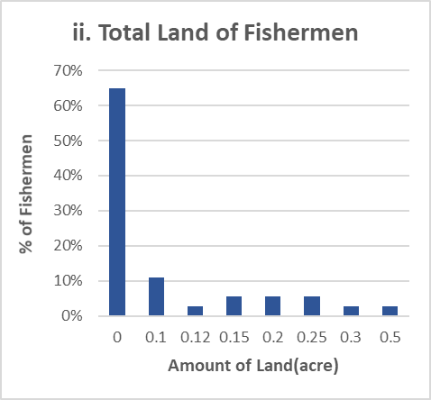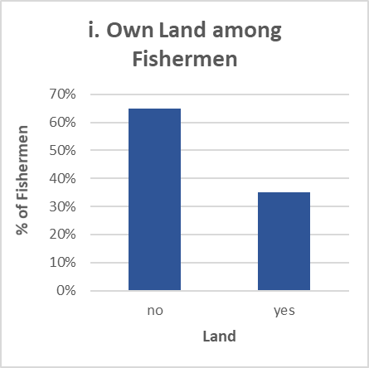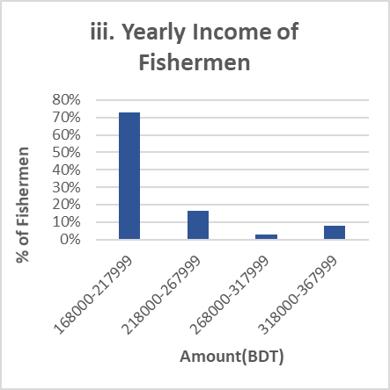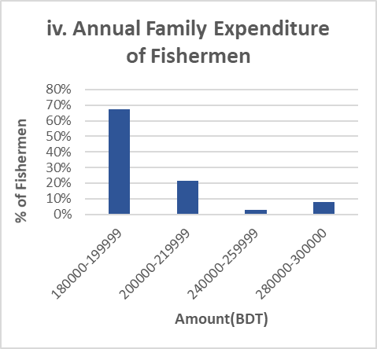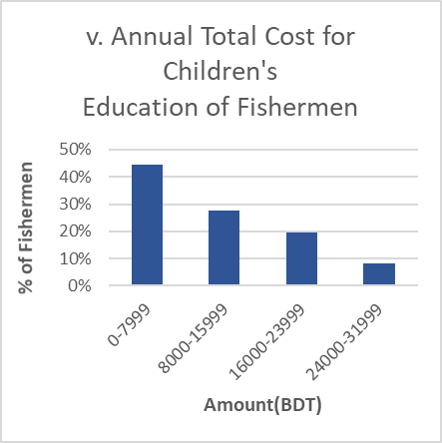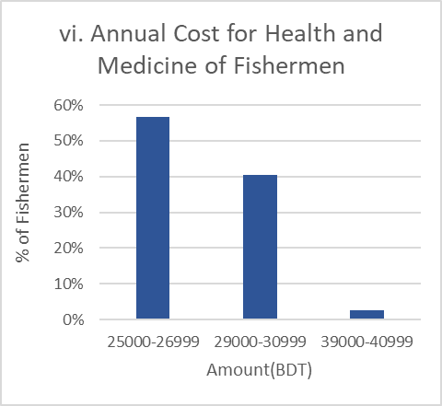

**Figure 4.5** Economic status of fishermen (vii-ix)

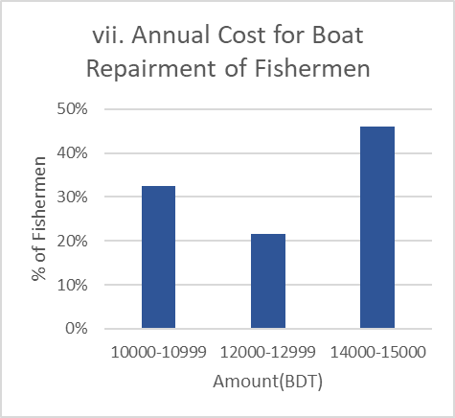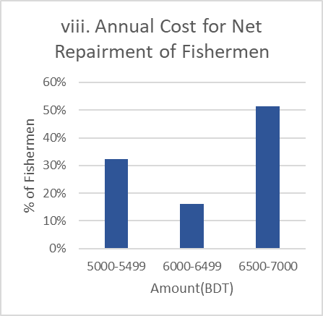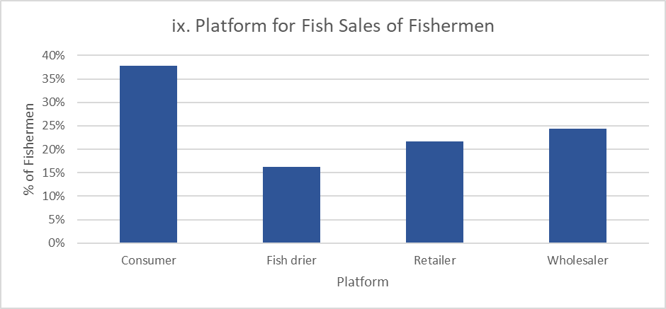

**4.1.3 Occupational Status**

**i. Working Hours Per Day**

Most fishermen report working 8 hours per day (3%), while others work 10 or even 12 hours. The long working hours suggest that fishing is a labor-intensive occupation, with some individuals needing to work extended hours to secure a sufficient catch. Longer working hours can lead to physical exhaustion and may negatively impact fishermen’s quality of life. This finding underscores the demanding nature of the profession, where income is often tied directly to the amount of time spent on the water. The following Figure 4.6 (i) shows the working hours of fishermen in a day.

**ii. Occupational Satisfaction**

Despite the challenges they face, 56% of fishermen report being satisfied with their occupation, while 44% express dissatisfaction. The mixed satisfaction levels may be influenced by factors such as income variability, working conditions, or the physically demanding nature of the job. Those who are satisfied may find fulfillment in the independence and traditional aspects of fishing, while the dissatisfaction expressed by others likely stems from the financial instability and physical strain associated with the profession. The following Figure 4.6 (ii) shows the satisfactory level of fishermen about their occupation.

**iii. Alternative Livelihoods Among Fishermen**

A significant portion (56%) of fishermen do not have alternative livelihoods, while 44% do. The lack of income diversification means that the majority of fishermen are highly dependent on fishing as their sole source of income. This exposes them to greater financial risk, particularly during off-seasons or times when fish stocks are low. For those with alternative livelihoods, there is likely greater financial stability, as they can rely on secondary sources of income to supplement their earnings from fishing, especially during lean periods. The following Figure 4.6 (iii) shows the alternative livelihoods among fishermen.

**4. Role of Women**

A significant proportion of women, 54% having no direct involvement in economic or fishing-related activities. 11% of women are engaged in household work, the largest activity besides having no role. Participation in fish-related tasks is minimal, with 5% involved in fish drying and 3% in drying fish and sewing cloth. Meanwhile, 8% of women contribute to household income through small businesses, sewing clothes, or rearing ducks, though only 3% are engaged in formal or informal jobs. The following Figure 4.6 (iv) shows the role of women in fishing.

**Figure 4.6** Occupational status of fishermen (i-iv)

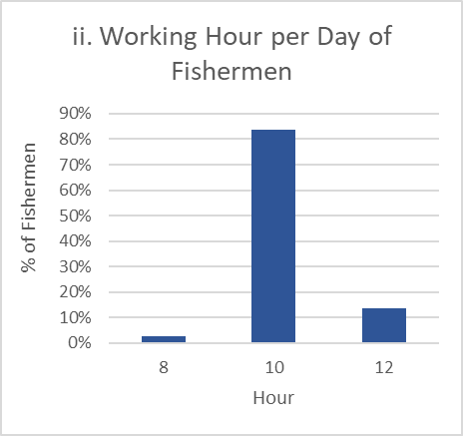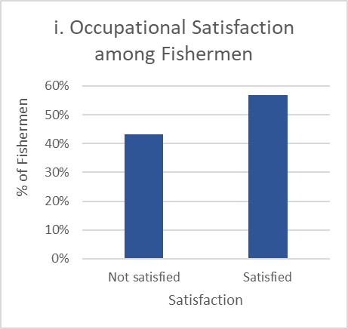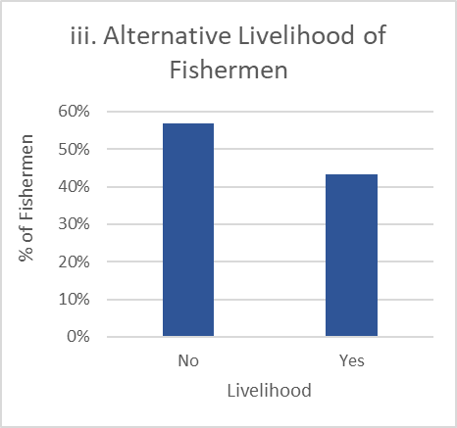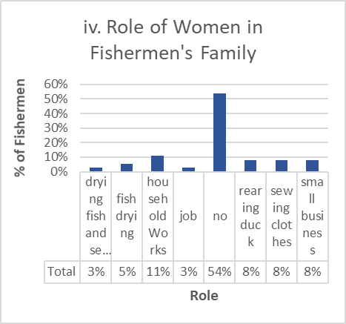

* 1. **Dry Fishers Community**

A total of 28 dry fishers were investigated in this research, providing insights into their personal, social, and economic status. The study aimed to understand the socio-economic dynamics of dry fishers in Ashuganj, highlighting the various factors influencing their livelihoods. The collected data encompassed aspects such as demographics, family structures, and community involvement, alongside economic factors like income levels, expenditure patterns, and asset ownership. This comprehensive approach allowed for a nuanced understanding of the challenges and opportunities faced by dry fishers, ultimately contributing to a broader assessment of their socio-economic well-being within the region.

**4.2.1 Personal and Social Status**

**i. Location**

The geographical distribution of dry fishers is concentrated in three main areas. Fifty percent of fishers are from Uttor Para, making it the most populous location. Thirty-five percent reside in Kandapara, and the remaining 15% are from Pashimpara. This shows that Uttor Para has the largest concentration of dry fishers. The following Figure 4.7 (i) shows the location of fishing.

**ii. Age Distribution**

The dry fishers’ range in age from 28 to 57 years. The largest age group, comprising 30% of the population, falls between 28 and 32 years. Twenty percent are between 33 and 37 years old, while 15% are between 38 and 42 years. Additionally, 10% are aged between 43 and 47, and an equal percentage are between 48 and 52 years. The remaining 15% are aged between 53 and 57 years. This data suggests that the dry fishing community consists of individuals primarily in their early to mid-30s. The following Figure 4.7 (ii) shows the age distribution of dry fishers.

**iii. Marital Status**

The marital status of the dry fishers reveals that the vast majority, 95%, are married, while only 5% are single. This indicates a predominantly family-oriented workforce within the dry fishing community. The following Figure 4.7 (iii) shows the marital status of dry fishers.

**iv. Experience**

The professional experience of dry fishers varies, with 35% having 10 years of experience, making this the most common experience level. Twenty percent of dry fishers have 5 years of experience, and an equal percentage, 20%, have been in the industry for 20 years. Fifteen percent of fishers have 15 years of experience, and 10% have 30 years, suggesting a broad range of experience levels, with a concentration in the mid-range of 10 years. The following Figure 4.7 (iv) shows the experience of dry fishers.

**v. Education**

The educational background of the dry fishers is diverse. A significant portion, 25%, have completed primary education, and an equal percentage have completed Secondary School Certificate (SSC) qualifications. Twenty percent have Junior School Certificate (JSC) qualifications, while 10% have completed Higher Secondary Certificate (HSC) education. Notably, 10% of dry fishers have not received formal education, indicating a varied educational profile. The following Figure 4.7 (v) shows the education level of dry fishers.

**vi. Religion**

In terms of religious composition, 80% of dry fishers identify as Hindu, while the remaining 20% are Muslim. This reflects the religious makeup of the community, with Hinduism being the dominant faith. The following Figure 4.7 (vi) shows the religion of dry fishers.

**vii. Family Type**

Family structure among the dry fishers is predominantly nuclear, with 75% of households following this family arrangement. In contrast, 25% of dry fishers belong to joint families, indicating a trend toward smaller, nuclear family units within the community. The following Figure 4.8 (vii) shows the family type of dry fishers.

**viii. Family Size**

Family sizes in the dry fisher community vary widely. The most common household sizes consist of 5 and 6 members, each representing 20% of the population. Households with 4 members make up 15% of the total. Families with 7 members account for 10%, while smaller family sizes of 2 and 3 members, as well as larger families of 8, 9, 10, and 12 members, each represent 5%. This distribution indicates that medium-sized families are the most common among dry fishers. The following Figure 4.8 (viii) shows the family size of dry fishers.

**ix. Children’s School Enrollment**

The analysis of school enrollment among the children of dry fishers indicates that a large majority of families ensure at least one child is enrolled in school. Specifically, 70% of families have one child enrolled, highlighting the emphasis on basic education. However, only 20% of families have two children attending school, and even fewer—5% each—have three or four children enrolled. This suggests that while education is a priority for some families, economic or logistical constraints may limit how many children can attend school beyond the first child. The smaller percentages for multiple enrollments may also point to challenges in affording school-related expenses for larger families. The following Figure 4.8 (ix) shows the enrollment of the school of children of dry fishers.

**x. School Dropout Children**

The dropout rate is generally low, with 90% of dry fisher families reporting no dropouts. Only 5% of families have one child who dropped out, and another 5% have two children who dropped out of school. This low dropout rate could reflect the importance of education within these communities, despite the economic challenges they face. The following Figure 4.8 (x) shows the percentage of dropout children of dry fishers from school.

**xi. Reason Behind Dropout of Dry Fishers’ Children**

School dropout rates among dry fishers’ children are minimal, with 90% of families reporting no dropouts, meaning their children have maintained continuous education. Of the 10% who did experience dropouts, the reasons were split equally between family issues and financial crises, each accounting for 5%. Family issues may include the need for children to assist in household or fishing-related activities, while financial crises likely reflect the high costs of schooling relative to the family’s income. This data indicates that, despite challenges, most dry fishers prioritize education. The following Figure 4.8 (xi) shows the reason for dropping children of dry fishers from school.

**xii. Earning Members of Dry Fishers’ Family**

In dry fishing families, the burden of earning typically falls on a single member. In 75% of families, there is only one income earner, reflecting a high dependency on that individual for financial stability. In contrast, 15% of families have three earning members, and 10% have two earners, showing that in a minority of cases, the financial load is shared among more members of the household. These statistics suggest that the majority of families may face financial vulnerability if the primary earner is unable to work due to illness or other reasons. The following Figure 4.8 (xii) shows the number of earning members in the dry fishers’ family.

**xiii. Health Facilities**

The health care options available to dry fishers are somewhat limited. 65% of the community primarily relies on pharmacies for medical care, suggesting that many opt for over-the-counter solutions rather than visiting a medical professional. This may be due to the affordability and accessibility of pharmacies compared to formal health facilities. 20% of dry fishers visit doctors, indicating that some individuals seek professional medical care when necessary. Another 15% rely on the Union Health Complex, which may offer more comprehensive but possibly less accessible health services. This reliance on non-doctor care suggests potential gaps in medical access or affordability. The following Figure 4.9 (xiii) shows the proportion of healthcare facilities that dry fishers obtain.

**xiv. Housing Condition**

Housing for dry fishers is predominantly modest, with 70% living in tinshed houses. These types of homes are typically inexpensive to construct but offer limited protection against harsh weather conditions. 15% of dry fishers reside in buildings, indicating a slightly higher standard of living for a minority. 10% live in semi-paka houses, which are partially built with durable materials, offering more stability than tinsheds. Only 5% of dry fishers live in well-furnished buildings, reflecting the small proportion of the population that has achieved a higher level of housing security. The following Figure 4.9 (xiv) shows the housing condition of dry fishers.

**Figure 4.7** Personal and social status of fish driers (i-vi)

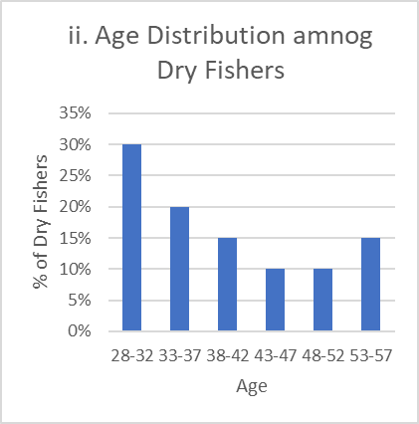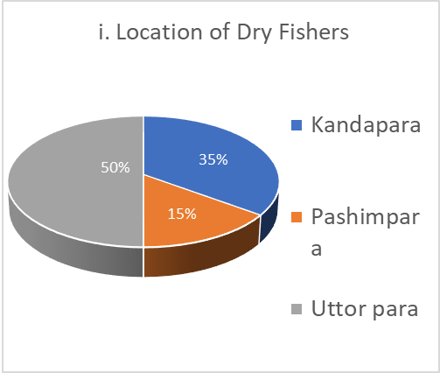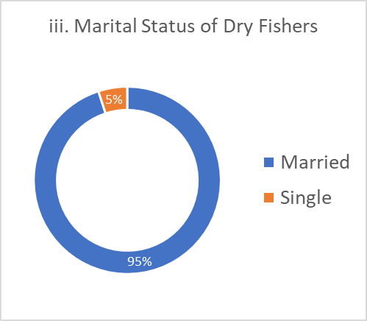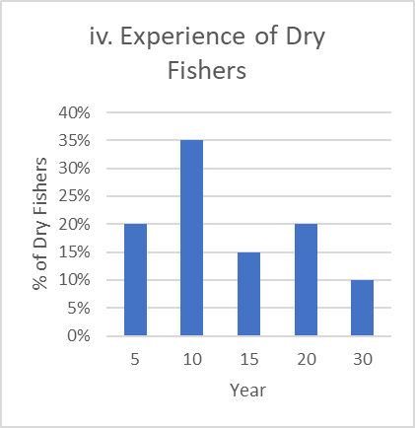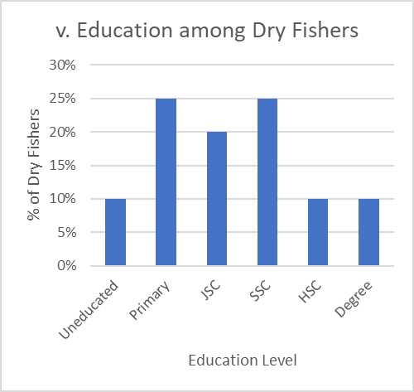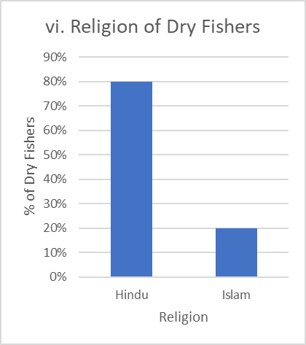

**Figure 4.8** Personal and social status of fish driers (vii-xii)

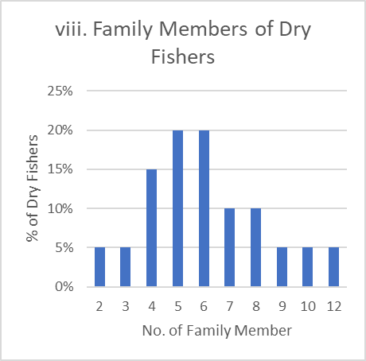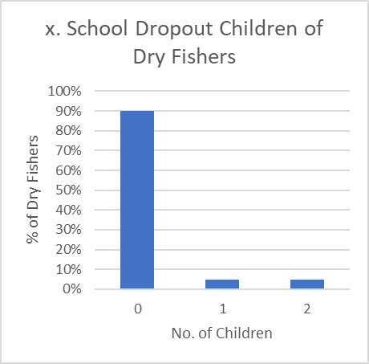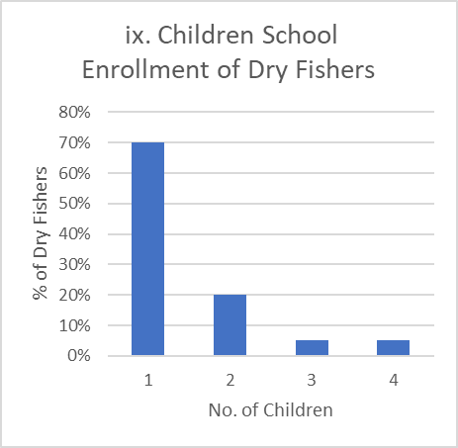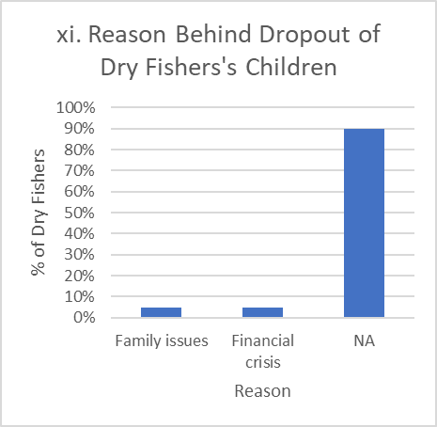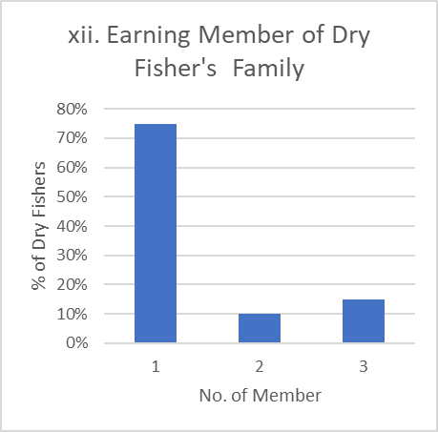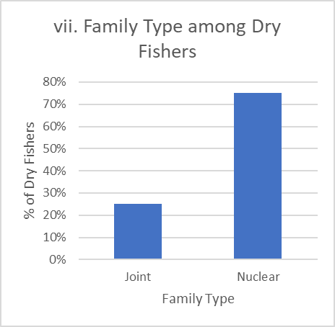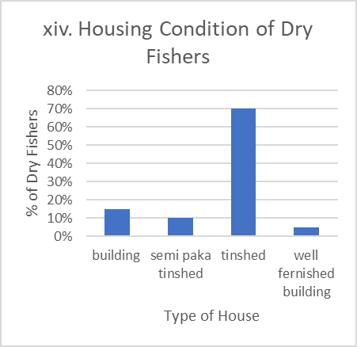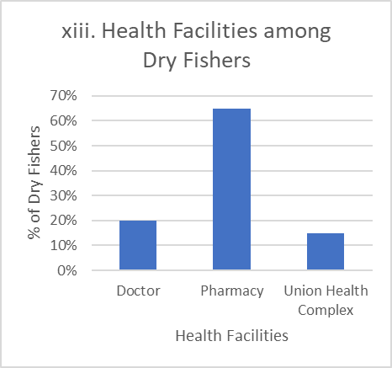

**Figure 4.9** Personal and social status of fish driers (xiii-xiv)

**4.2.2 Economic status**

**i. Land Ownership**

Land ownership among dry fishers is fairly common, with 75% owning their own land. This indicates a significant level of asset ownership, which can contribute to financial stability and provide space for housing or small-scale agriculture. The 25% who do not own land likely represent a more vulnerable segment of the population, as land ownership can be a crucial buffer against economic instability in rural communities. The following Figure 4.10 (i) shows the landowners among dry fishers.

**ii. Yearly Income**

The income distribution among dry fishers indicates that most families earn modestly. 80% of families earn between 900,000 and 1,899,999 BDT annually, reflecting a reliance on subsistence income levels. 10% earn between 1,900,000 and 2,899,999 BDT, and another 10% earn between 2,900,000 and 3,899,999 BDT, indicating that a small proportion of the community benefits from a higher income, possibly due to larger-scale operations or diversified income sources. The following Figure 4.10 (ii) shows the yearly income of dry fishers.

**iii. Annual Costs for Preparation of Drying Place**

Dry fishers face significant costs in preparing their drying places. 30% spend between 70,000 and 79,999 BDT, while 30% spend between 80,000 and 89,999 BDT. 25% of families spend between 90,000 and 100,000 BDT, and 15% spend between 60,000 and 69,999 BDT. These expenditures are necessary to maintain the spaces where fish are processed, reflecting the importance of infrastructure in the dry fish business. The following Figure 4.10 (iii) shows the annual costs for the preparation of drying place.

**iv. Fish Buying Costs**

The cost of purchasing fish for dry fishers varies, but 75% spend between 600,000 and 1,099,999 BDT annually on this business expense. This suggests that the majority of fishers operate on a relatively modest budget. A smaller percentage, 10% each, spend between 1,100,000 and 1,599,999 BDT and between 1,600,000 and 2,099,999 BDT. Only 5% spend between 2,100,000 and 2,599,999 BDT, suggesting that larger-scale operations are less common among this group. The following Figure 4.10 (iv) shows the annual fish buying costs of dry fishers.

**v. Annual Food Costs**

Annual food costs are a major part of dry fishers’ budgets, with 40% of families spending between 200,000 and 249,999 BDT. 25% each spend between 150,000 and 199,999 BDT and between 250,000 and 300,000 BDT, while 10% spend between 100,000 and 149,999 BDT. The wide range in food expenditure reflects variations in family size, food prices, and purchasing power within the community. The following Figure 4.10 (v) shows the annual food costs of dry fishers.

**vi. Annual Children's Education Costs**

The cost of education is a significant expenditure for dry fishers, with 75% of families spending between 10,000 and 99,999 BDT annually on their children’s schooling. Only 10% spend between 100,000 and 189,999 BDT, while 5% spend between 190,000 and 279,999 BDT. Another 5% of families spend between 280,000 and 459,999 BDT on education, reflecting that while education is prioritized, the majority of families are managing their expenses within lower to moderate brackets. The following Figure 4.10 (vi) shows the annual children’s education costs of dry fishers.

**vii. Annual Health and Medicine Costs**

Health and medical expenses are substantial for most dry fishers. 75% of families spend between 30,000 and 40,000 BDT annually on healthcare, suggesting that illness and medical needs are a significant financial concern. 15% spend between 20,000 and 29,999 BDT, and 10% spend between 10,000 and 19,999 BDT. These costs likely include treatment for common diseases and injuries related to fishing activities. The following Figure 4.11 (vii) shows the annual healthcare and medicine costs of dry fishers.

**viii. Annual Savings**

Savings data shows that 50% of dry fishers save between 60,000 and 149,999 BDT annually, indicating that half of the community manages to set aside a moderate amount of their income for future needs. 35% save between 150,000 and 239,999 BDT, while 10% save between 240,000 and 329,999 BDT. Only 5% save between 330,000 and 419,999 BDT, reflecting that higher savings levels are less common. The following Figure 4.11 (viii) shows the annual savings of dry fishers.

**ix. Selling Platforms for Dry Fish**

The majority of dry fishers, 75%, sell their fish through wholesalers, which indicates a strong reliance on this distribution channel to access markets. 25% of fishers sell their products to retailers, reflecting that direct-to-consumer sales are less common but still play a role in the fishers' income strategies. The following Figure 4.11 (ix) shows the selling platforms of dry fish.

**Figure 4.10** Economic status of fish driers (i-vi)

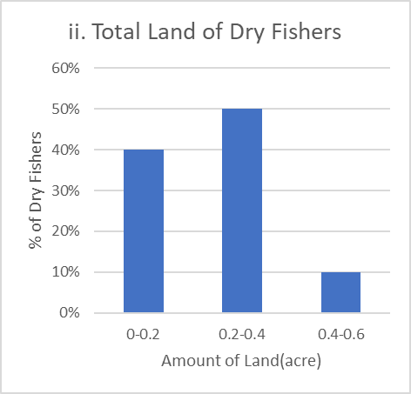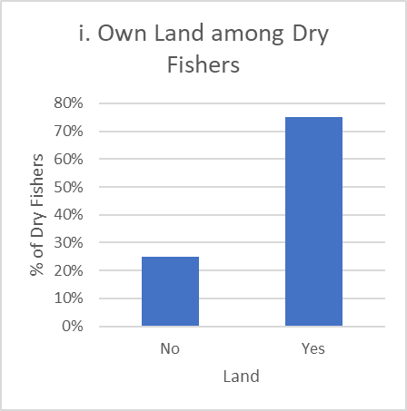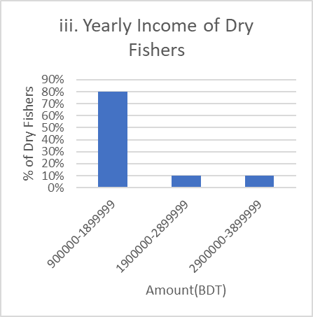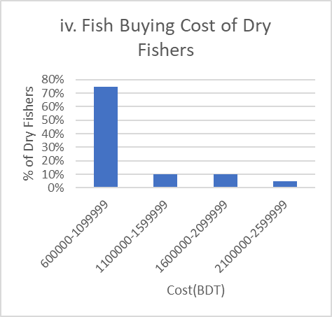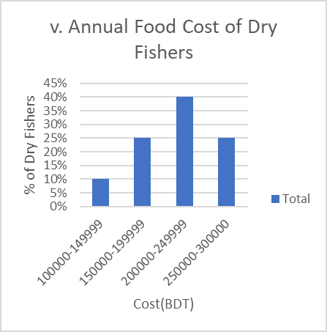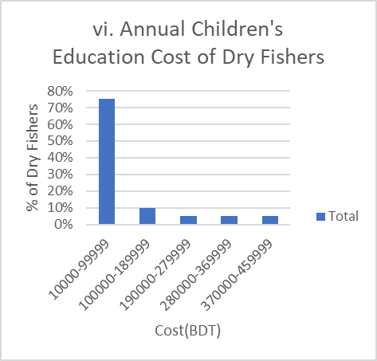

**Figure 4.11** Economic status of fish driers (vii-ix)

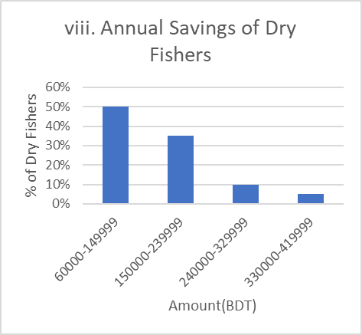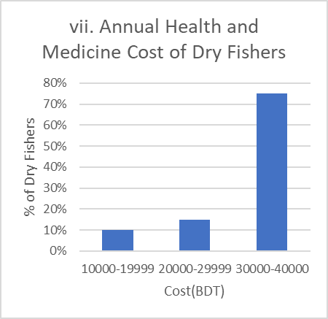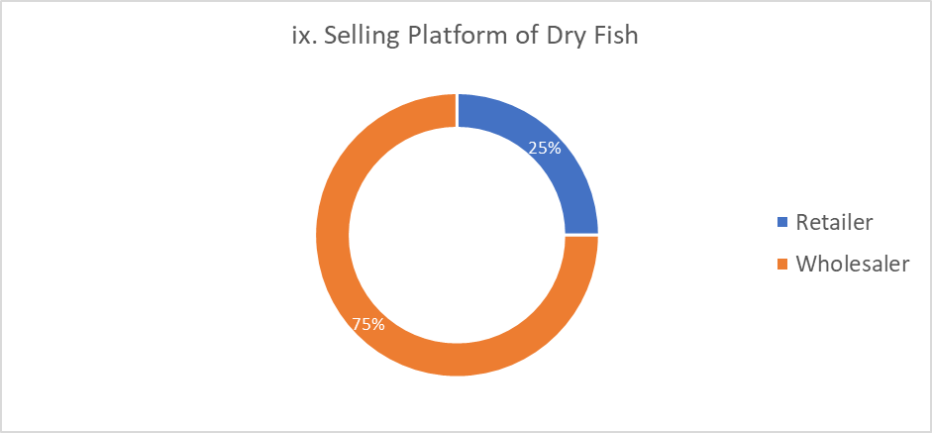

**4.2.3 Occupational status**

**i. Occupational Satisfaction**

Most dry fishers, 70%, are satisfied with their occupation, suggesting that despite the challenges, many find fulfillment in their work or view it as a stable livelihood. However, 30% are not satisfied, which could be due to low income, difficult working conditions, or lack of growth opportunities in the industry. The following Figure 4.12 (i) shows the satisfactory level of dry fishers in their occupation.

**ii. Working Hours per Day**

Dry fishers generally work long hours, with 65% working 10 hours per day. 30% of fishers work 12-hour days, and 5% work 11-hour days, highlighting the demanding nature of this profession, which requires significant time investment. The following Figure 4.12 (ii) shows the working hours of dry fishers in a day.

**iii. Contribution of Children in Dry Fisher's Families**

Children in dry fisher families play a significant role in the business, with 40% involved in sorting fish and 30% assisting in drying. 25% of children contribute by guarding the fish, while only 5% are not involved. This indicates that child labor is common in these families, with children contributing to various stages of the fish drying process. The following Figure 4.12 (iii) shows the contribution of children in dry fishers’ families.

**iv. Contribution of Women in Dry Fisher's Families**

Women also play an important role in dry fishing activities. 30% are involved in cleaning fish, while 25% assist in drying. 15% contribute by grading the fish, and 10% are involved in sorting. Smaller proportions, 5% participate in dressing and gutting fish, while 10% of women are not involved in the fishing business at all. This data highlights the significant contribution of women to fish processing and preparation. The following Figure 4.12 (iv) shows the contribution of women in dry fishers’ families.

**v. Common Diseases**

The most commonly reported illnesses among dry fishers include skin diseases, affecting 65% of the population, followed by fever (20%) and colds (15%). These health issues are likely related to the physically demanding and outdoor nature of the work. Skin diseases are less frequently mentioned, though they could still pose risks given the working conditions. The following Figure 4.12 (iv) shows the common diseases in dry fishers’ families.

**Figure 4.12** Occupational status of fish driers (i-v)

**Chapter 5**

**Discussion**

* **Socio-economic status of fishermen of Ashuganj**
* **Socio-economic status of fish driers of Ashuganj**
* **Comparison between the socio-economic status of fishermen and dry fishers in Ashuganj**

**Chapter 5**

**Discussion**

The analysis of the personal, social, economic, and occupational statuses of the fishermen and dry fishers’ community of Ashuganj upazila provide important insights into their livelihoods, challenges, and opportunities. The findings highlight the unique social dynamics, economic vulnerabilities, and occupational conditions that shape the lives of fishermen and fish driers. This discussion will critically examine these factors, making comparisons where appropriate and drawing attention to areas that require intervention.

**5.1 Socio-economic status of fishermen of Ashuganj**

The fishermen community has a relatively young workforce, with the majority (32%) between the ages of 24 and 28 years, indicating a high level of physical demand in the profession. In contrast, the dry fishers are slightly older, with the largest age group (30%) falling between 28 and 32 years, and a broader age range extending up to 57 years​. It suggests that while both occupations require physical labor, the dry fishing profession allows for a wider range of ages, possibly due to its less physically demanding nature compared to active fishing. Ahmed (1996) in Tangail and Ahmed (1999) in coastal region reported (66%) and (70%) under 40 years age respectively. Kamal et al. (2023) in Nazirtek, Cox’s Bazar reported that the highest number of people age (60%) were below 35 years. This is almost same with those studies.

From the study it was found that majority of people of the study are married (72%) and 28% are unmarried. Different studies were found Ahamed (1996) in Tangail, Mannu (1999) in Kuakata and Shamima (2000) in Gallamari observed married fishermen were (94%), (92%) and (70%) respectively. Momotaz (2009) studied showed on the socio-economic condition of small indigenous species beneficiaries at three areas showed that (84%) fishermen were married and rest unmarried (16%). Hossain (2009) studied on the socio-economic condition of the fish farmers in Jessore District showed that (68%) fishermen were married and rest were (32%) unmarried. So, the present study is more or less related with those studies.

Religion can have a significant impact on the socio-cultural environment of a community and can influence or modify social change. According to the current fishermen survey, 32% of people are Muslims and 68% are Hindu. Kabir (2009) recorded 82% Hindus and the rest 18% Muslims at fishermen community of Sandwip Island.

In the study of fishermen family, it was found that fishermen (30%) live in joint families and only 70% live with nuclear family. Barua et al. (2022) recorded that 21% of tribal fishermen were single-family and 79% were joint-family. Karuppusamy and Karthikeyan (2017) found that 65% of fishermen were nuclear families and 35% were joint family on the contrary, Dry fishers live with 75% lived in nuclear families and remaining 25% live with joint family.

The low rate of school enrollment among fishermen’s children is alarming, with 37% not enrolled in school​. This suggests that many children are required to contribute to the household income rather than pursuing education. The dropout rate of 27% further highlights the barriers to education, such as financial hardship and the need for child labor​. Initiatives that provide financial aid or alternative child labor solutions, along with educational scholarships, are essential to break the cycle of poverty and provide future generations with better opportunities outside of the fishing industry.

In the study of Fishermen area, the result finds that 91% houses are tinshed and 9% semi paka and roof shed building.Billah et al. (2018) mentioned that houses of fishermen were of two main types as, Tin shed house (68%) and concrete house (32%).

In the study of fishermen area, there was found 14% JSC pass, (8%) S.S.C pass, (24%) had no education and (54%) had passed primary level. Rahman et al. (2002) revealed that the majority of the fishermen (74.19%) were illiterate, with only a small portion having minimal education—12.90% were semiliterate, and another 12.90% had completed primary education. None of the fishermen had attended secondary school. Dry fishers people have 25% primary, 25% SSC pass, 20% JSC, 10% each HSC pass, Degree pass and Uneducated also.

Access to healthcare is limited among fishermen, with only 3% visiting doctors and the majority relying on pharmacies​. This reliance on self-medication suggests gaps in the availability or affordability of professional healthcare services, which could lead to the mismanagement of health issues.

In study area fishermen and dry fishers get 100% facilities to use electricity. Shamima (2000) reported that (20%) used electricity in Gallamary fishing community, Khulna. Momotaz (2009) studies showed that (90%) fishermen had facility of electricity and (10%) fishermen didn’t get to use electricity. Hossain (2009) studies showed that (95%) fishermen had facility of electricity and (5%) fishermen didn’t get facilities to use electricity. So, the present study is completely different to those studies.

The study area was found that 100% of the fishermen and dry fishers used tube-well water for drinking. Ahmed (1999) mentioned that most farmers used pond water due to lack of tube-well in coastal area. This result is different from present result.

Condition of toilet is another important indicator of health status and the result reveals that 78% use sanitary latrin and 22% respondent are found to use open acha latrin. Hossain et al. (2004) reported that 81% households were found to have sanitary latrin and 2% kacha latrin at North Kattoli fishermen community which is not in agreement with the result of the present study. However, it can be said that proper initiatives are required to improve the health and sanitation condition of the fishers.

Fishermen in Ashuganj face significant economic vulnerability, with 65% not owning any land and relying solely on fishing for their livelihoods​. In contrast, 75% of dry fishers own land, offering them financial stability and opportunities for income diversification through small-scale agriculture​. Ahamed (1999) was found about (34%) fishermen depending on farming as subsidiary occupation in Tangail. In the present study area maximum area of fishermen had maximum 0.50 acres. It was found that the number of fishermen (33%) had below 0.50 acres lands, while 65% fishermen had no lands and 2% fishermen had 0.50 acres lands. Momotaz (2009) was found that the highest number of fishermen (60%) had above 0.50 acres lands. So, this result is different from present result.

Fishermen in Ashuganj have lower income levels, with 72% earning between BDT 168,000 and 217,999 annually, placing them in the lower-income and limiting their ability to save or invest​. These results were more than the findings of Hossain et al. (2009), Billah et al. (2018) and Haque et al. (2019).

The costs associated with maintaining boats and fishing nets are significant, with fishermen spending BDT 10,000-15,000 on boat repairs and BDT 5,000-7,000 on net repairs annually​. These expenses are essential for the continuation of fishing activities but also reduce the funds available for other critical areas, such as healthcare and education. The data highlights the need for financial support mechanisms, such as low-interest loans or subsidies for boat and gear maintenance, to alleviate the economic burden on fishermen.

Fishermen report long working hours, with some working up to 12 hours a day​. The demanding nature of the profession is physically exhausting and may have long-term health implications. Despite these challenges, 56% of fishermen express satisfaction with their occupation​. This may stem from the independence and traditional aspects of the job, although those dissatisfied are likely affected by the financial instability and physical toll of the work. The mixed levels of satisfaction suggest that while fishing remains a culturally significant occupation, efforts to improve working conditions and income stability are needed.

A significant portion (56%) of fishermen do not have alternative sources of income, making them highly dependent on fishing​. This lack of income diversification exposes them to economic risks, particularly during off-seasons or when fish stocks are low. Providing training for alternative livelihoods, such as fish processing or small-scale agriculture, could help reduce their dependence on fishing and provide more stable income streams.

Overall, the fishermen community faces numerous challenges related to economic vulnerability, limited access to healthcare and education, and the physically demanding nature of their occupation. While some express satisfaction with their work, the majority remain financially insecure due to low incomes, high costs, and the lack of alternative livelihoods. Addressing these challenges will require a multi-faceted approach, including improved healthcare and sanitation, access to education, financial support for fishing operations, and the introduction of alternative income opportunities. By implementing these measures, the livelihoods of fishermen can be stabilized, and their quality of life significantly improved.

**5.2 Socio-economic status of fish driers of Ashuganj**

The dry fishers’ community in Ashuganj presents a complex socio-economic landscape shaped by their location, age distribution, family dynamics, economic constraints, and occupational challenges. By analyzing various aspects such as education, income, health, and family structure, it becomes evident that while the community strives for stability, it faces significant hurdles that impact their overall well-being and economic mobility.

The dry fishers of Ashuganj are primarily concentrated in Uttor Para (50%), with smaller populations in Kandapara (35%) and Pashimpara (15%)​. This clustering indicates that economic activities related to dry fishing are heavily localized, likely driven by geographical advantages such as proximity to fish drying areas or market access.

The age distribution shows that the largest segment of dry fishers (30%) is between 28 and 32 years, while the overall age range spans from 28 to 57 years​. The predominance of individuals in their early 30s suggests that dry fishing is a physically demanding job suited to younger adults. However, the presence of older individuals indicates that the profession allows for longer-term participation compared to more strenuous physical jobs like offshore fishing.

Dried fishers survey showed that 80% of dry fishers were Hindu, while the remaining 20% were Muslim.Kamal et al. (2023) recorded that 100% dried fishers were muslims. It suggests a gradual demographic changes or differences in community composition between regions or timeframes.

An overwhelming 95% of dry fishers are married, reflecting a predominantly family-oriented community​. This high rate of marriage suggests stability and familial obligations, where family units play a crucial role in the workforce. 75% of households follow a nuclear family structure, while 25% are joint families​. Kamal et al. (2023) recorded that dry fishers’ lived with 36% lived in joint families and remaining 64% lived with nuclear family.

The shift towards nuclear families could indicate modern economic pressures and the need for smaller, more manageable households.

The family sizes vary, but medium-sized families with 5 or 6 members are the most common, representing 20% of the population​. This distribution highlights the significance of family labor in the dry fishing process, where multiple family members contribute to income-generating activities.

The educational attainment among dry fishers is diverse, with 25% having completed primary education and 25% having SSC qualifications​. Notably, 10% have not received formal education. While some individuals in the community prioritize education, a significant portion struggles with access to higher levels of schooling due to financial constraints or the need for labor within the family.

Despite these challenges, 70% of families ensure at least one child is enrolled in school​. The low dropout rate of 10% further emphasizes the value placed on education. However, economic or logistical constraints limit the number of children who can attend school, particularly in larger families. This reflects a balance between the desire for education and the financial realities faced by these families.

Access to healthcare is limited, with 65% of dry fishers relying on pharmacies for medical care. Only 20% visit doctors, indicating a lack of access to professional medical services, possibly due to affordability or the remoteness of health facilities. This reliance on pharmacies points to a need for improved healthcare infrastructure within the community.

Housing conditions are modest, with 70% of dry fishers living in tinshed houses, which are inexpensive to construct but offer little protection against harsh weather​. Only 15% of the community resides in more secure buildings, reflecting the economic disparity within the population. The prevalence of temporary housing structures highlights the vulnerability of dry fishers to environmental risks, such as flooding or storms.

75% of dry fishers own land, which provides a critical buffer against economic instability​. Land ownership allows for housing security and small-scale agriculture, contributing to the financial stability of many families. However, the 25% who do not own land are more vulnerable, relying solely on dry fishing for their livelihood.

80% of dry fishers earn between BDT 900,000 and 1,899,999, reflecting higher income potential within the dry fishing community​. These results were more than the findings of Hossain et al. (2009), Billah et al. (2018) and Haque et al. (2019). A small portion of the population earns higher incomes, likely due to larger-scale operations or diversification of income sources. This income disparity reflects the varying degrees of success in the dry fishing industry, where some individuals can capitalize on better market access or increased production.

The costs associated with preparing drying places are significant, with 30% spending between 70,000 and 79,999 BDT, and 25% spending between 90,000 and 100,000 BDT annually​. These expenditures underscore the capital-intensive nature of dry fishing, where infrastructure maintenance is critical for business success.

Food expenses account for a large part of household budgets, with 40% of families spending between 200,000 and 249,999 BDT annually​. This reflects the basic subsistence level of many families, where food costs take up a significant portion of income, leaving little room for savings or investment.

Education remains a significant expenditure, with 75% of families spending between 10,000 and 99,999 BDT annually on their children's schooling​. The focus on education indicates that despite economic constraints, many dry fishers view schooling as a potential avenue for breaking the cycle of poverty. However, the cost of education can strain family budgets, particularly for those with multiple children.

Healthcare expenses are another financial burden, with 75% of families spending between 30,000 and 40,000 BDT annually​. The high cost of medical care suggests that illness or injury can have a significant impact on family finances, further emphasizing the need for improved healthcare services and affordable access to medical professionals.

50% of dry fishers save between 60,000 and 149,999 BDT annually​, which suggests a moderate capacity for savings among half the population. However, a significant portion of the community struggles to save, highlighting the precarious nature of their economic situation. The reliance on a single income earner in 75% of households further exacerbates this vulnerability, as any disruption to the primary earner’s ability to work could lead to financial hardship​.

Most dry fishers (70%) report satisfaction with their occupation​. This could be due to the relative stability of the profession compared to more volatile industries. However, 30% are dissatisfied, likely due to low income, long working hours, or lack of growth opportunities. The demanding nature of the job is evident, with 65% working 10 hours per day, and 30% working 12-hour shifts​.

Both children and women play significant roles in dry fishing. 40% of children help with sorting fish, while 30% assist in drying​. Similarly, 30% of women are involved in cleaning fish, and 25% assist in drying​. This heavy reliance on family labor underscores the economic pressures within the community, where every member is expected to contribute to the household’s income.

The physically demanding nature of dry fishing leads to common health issues such as headaches (65%), fever (20%), and colds (15%)​. These ailments are likely caused by prolonged exposure to the elements and strenuous labor, which further exacerbates the financial and health-related challenges faced by the community.

Overall, the socio-economic status of the dry fishers in Ashuganj is shaped by a combination of modest income levels, family labor contributions, and a reliance on traditional fishing practices. While many families own land and prioritize education, the community faces significant challenges, including high healthcare and education costs, limited housing security, and financial vulnerability. The reliance on a single earner in most households highlights the precarious nature of their economic stability, while the use of family labor reflects the financial pressures within the community. To improve their socio-economic standing, targeted interventions in healthcare access, educational support, and income diversification are essential.

**5.3 Comparison Between the Socio-economic Status of Fishermen and Dry Fishers in Ashuganj Upazila**

**5.3.1 Personal and Social Status**

The fishermen community has a relatively young workforce, with the majority (32%) between the ages of 24 and 28 years, indicating a high level of physical demand in the profession. In contrast, the dry fishers are slightly older, with the largest age group (30%) falling between 28 and 32 years, and a broader age range extending up to 57 years​. This suggests that while both occupations require physical labor, the dry fishing profession allows for a wider range of ages, possibly due to its less physically demanding nature compared to active fishing.

A larger proportion of dry fishers are married, with 95% being married compared to 72% of fishermen​. This indicates that dry fishing may be more conducive to family life, perhaps due to its more stable work environment. Fishermen, facing more physically demanding and possibly riskier work conditions, might have a higher percentage of single individuals, potentially due to the lifestyle challenges associated with the profession.

The fishermen community tends to have a veteran workforce, with significant portions having 15-19 years and 30-35 years of experience (each 8.1%)​. In comparison, dry fishers exhibit a broader distribution of experience, with 35% having 10 years of experience, followed by 20% each with 5 or 20 years of experience​. The data shows that while both professions require extensive experience, dry fishers tend to have more mid-level experience, whereas fishermen have longer tenure in the industry, likely due to the specialized skills required for active fishing.

Both communities display low levels of educational attainment. Among fishermen, 45% have only completed primary education, and 9% have no formal education​. Dry fishers fare slightly better in educational distribution, with 25% completing primary education and 25% achieving Secondary School Certificate (SSC) qualifications​. This suggests that dry fishers might have better access to education or less disruption in their schooling, potentially due to the less migratory nature of their work compared to fishermen, who may be out at sea for extended periods.

The religious compositions of both communities are similar, with fishermen being 67% Hindu and 32% Muslim, while 80% of dry fishers are Hindu and 20% are Muslim​. This slight variation in religious makeup reflects the broader regional demographics and suggests that both communities share common cultural and religious practices, which may influence their social cohesion and traditional ways of life.

Both communities show a predominance of nuclear families. 75% of dry fishers live in nuclear families, compared to fishermen, where 26 households follow a nuclear family structure​. However, fishermen show a greater presence of joint families (11 households), likely indicating that in fishing, family labor might be more crucial, requiring larger household units to manage the demanding nature of the profession. In dry fishing, smaller nuclear units may be more economically viable due to the relatively more stable work environment.

Family sizes differ slightly between the two communities. Among fishermen, the most common family size is 2-3 members (8.1%), with some households reaching 10 or more members (5.4%)​. In contrast, dry fishers typically have larger family sizes, with 5 and 6 members being the most common at 20% each​. This could indicate that dry fishing supports slightly larger families, perhaps due to a less physically taxing work environment that allows for more family involvement in the business.

There is a stark difference in school enrollment rates between the two communities. 70% of dry fishers ensure at least one child is enrolled in school​, while 37% of fishermen's children are not enrolled​. This suggests that dry fishing families might prioritize education more, likely due to greater financial stability, allowing them to invest in their children's schooling. For fishermen, economic constraints and the need for children to contribute to household income may limit their ability to prioritize education.

Both communities face challenges in education, but fishermen have a higher dropout rate (27%) compared to only 10% of dry fishers​​. This reflects the more significant financial pressures on fishermen, which may force their children out of school to work. In contrast, dry fishers seem to manage education better, with fewer dropouts, indicating a stronger emphasis on continuing education despite economic challenges.

Both communities rely heavily on pharmacies for healthcare, but the reliance is higher among dry fishers (65%)​, compared to fishermen, where 2.7% access healthcare through doctors​. This shows that both groups face significant barriers to formal healthcare, but dry fishers might have slightly better access to over-the-counter solutions. However, the low access to professional medical services indicates a widespread healthcare challenge in both communities.

Both communities live in tinshed structures, with 91% of fishermen living in such housing compared to 70% of fish driers​​. However, 15% of dry fishers live in buildings, indicating slightly better housing conditions for a minority of the population. The predominance of semi-permanent structures highlights the modest living conditions in both groups, which are vulnerable to environmental risks, such as storms and flooding.

In a nutshell, the comparison between the fishermen and dry fishers’ communities in Ashuganj Upazila reveals both similarities and differences in their personal and social statuses. While both communities face economic and social challenges, such as limited education and healthcare access, dry fishers generally have better educational outcomes, slightly larger family sizes, and improved housing conditions. On the other hand, fishermen, with a younger workforce and higher dropout rates, struggle with greater financial instability, which impacts their children’s education and overall family well-being. Addressing these challenges would require targeted interventions, such as improving access to education, healthcare, and more stable income opportunities for both groups.

**5.3.2 Economic Status**

Fishermen in Ashuganj face significant economic vulnerability, with 64% not owning any land and relying solely on fishing for their livelihoods​. In contrast, 75% of dry fishers own land, offering them financial stability and opportunities for income diversification through small-scale agriculture​. The lack of land ownership among fishermen limits their ability to withstand economic shocks, while dry fishers are better positioned to buffer against financial instability through their land assets.

Fishermen in Ashuganj have lower income levels, with 72% earning between BDT 168,000 and 217,999 annually, placing them in the lower-income and limiting their ability to save or invest​. Conversely, 80% of dry fishers earn between BDT 900,000 and 1,899,999, reflecting higher income potential within the dry fishing community​. This disparity in income indicates that dry fishing offers more lucrative opportunities, while fishermen struggle with the instability of their earnings.

Fishermen's family expenditures are high, with most spending between BDT 280,000 and 300,000 annually, creating financial stress that hampers savings and investment​. Dry fishers, while facing significant costs in preparing drying spaces, manage their expenditures more effectively due to higher incomes, with 30% spending between BDT 70,000 and 79,999 on drying place preparations​. This suggests that dry fishers have a better balance between income and expenditure, allowing for more financial flexibility.

Fishermen spend between BDT 24,000 and 31,999 annually on their children's education, prioritizing schooling despite financial hardships​. Dry fishers, on the other hand, manage to keep education costs relatively moderate, with 75% spending between BDT 10,000 and 99,999. The higher income among dry fishers likely allows them to allocate more resources toward education without the same level of financial strain experienced by fishermen.

Both communities face significant healthcare costs, with 2.7% of fishermen spending between BDT 39,000 and 40,999 annually​, while 75% of dry fishers spend between BDT 30,000 and 40,000​. Despite higher incomes, dry fishers, like fishermen, struggle with the financial burden of healthcare, indicating a need for better access to affordable medical services for both groups.

Fishermen incur substantial costs for maintaining their boats and nets, with 45% spending BDT 14,000 to 15,000 annually on boat repairs​. In contrast, dry fishers face costs related to purchasing fish and preparing drying places, with 75% spending between BDT 600,000 and 1,099,999 annually on fish purchases​. While fishermen struggle with high maintenance costs, dry fishers' expenses are more focused on processing infrastructure, reflecting the different financial burdens of their respective trades.

Fishermen primarily sell their fish directly to consumers (37%) or through intermediaries like wholesalers and retailers​. Dry fishers rely heavily on wholesalers, with 75% using this platform for sales​. The reliance on wholesalers provides dry fishers with more stable market access, whereas fishermen's income fluctuates based on their ability to sell directly or through intermediaries, often at lower prices.

Savings are more common among dry fishers, with 50% saving between BDT 60,000 and 149,999 annually​. In contrast, fishermen struggle to save due to low-income levels and high expenses​. This suggests that dry fishers are better equipped to set aside funds for future needs, while fishermen remain more financially vulnerable due to their limited savings capacity.

In a whole, it is clear that dry fishers enjoy greater financial stability and land ownership, leading to more opportunities for savings and income diversification. Dry fishers earn significantly higher incomes, face fewer operational costs related to boat and gear maintenance, and are more likely to own land, which provides a buffer against economic shocks. Fishermen, by contrast, remain economically vulnerable, with the majority lacking land ownership, facing high costs for boat and net repairs, and relying heavily on fishing for survival. The financial instability of fishermen is further compounded by their lower incomes and higher expenditure on family needs, healthcare, and fishing gear. Improving the economic prospects of fishermen will require targeted interventions, such as providing access to affordable credit for equipment, supporting alternative income-generating activities during off-seasons, and enhancing access to healthcare and education. For dry fishers, continued investment in infrastructure and market access will be crucial for maintaining their financial stability.

**5.3.3 Occupational Status**

Fishermen and dry fishers both work long hours, reflecting the labor-intensive nature of their occupations. Most fishermen work 8 hours per day (2.7%), but many work extended shifts of 10 or 12 hours to secure a sufficient catch​. In comparison, 65% of dry fishers work 10 hours per day, with 30% working 12-hour days​. The need for long working hours in both professions underscores the physical and time demands placed on these workers, though dry fishers more consistently report longer hours of work than fishermen.

Occupational satisfaction is notably higher among dry fishers, with 70% reporting satisfaction with their jobs​, compared to 56% of fishermen​. This higher satisfaction among dry fishers could be attributed to more stability in their livelihood, despite the challenges they face. In contrast, dissatisfaction among 43% of fishermen likely stems from financial instability and the physically demanding nature of their work, which is closely tied to unpredictable fishing seasons and income fluctuations.

A significant 56% of fishermen lack alternative livelihoods, relying solely on fishing as their primary income source​. This dependence increases their financial vulnerability, particularly during off-seasons. In contrast, there is no specific data on alternative livelihoods for dry fishers, but their higher occupational satisfaction might suggest more stability, possibly reducing the immediate need for diversifying income streams.

Dry fishers heavily involve their families in the business. 40% of children contribute by sorting fish, and 30% assist in drying, highlighting the prevalence of child labor in this community​. Additionally, 30% of women are involved in cleaning fish, and 25% assist in drying​. In comparison, there is no mention of significant family involvement among fishermen, suggesting that dry fishing relies more on collective family labor, especially in the processing stages, than active fishing.

Both fishermen and dry fishers experience health challenges due to the physically demanding nature of their work. Among dry fishers, 65% report headaches, followed by fever (20%) and colds (15%)​, which are likely caused by prolonged exposure to outdoor conditions. Although specific health data for fishermen is not provided, their long working hours and physically strenuous work likely result in similar occupational health issues, exacerbating their economic hardships.

Overall, both fishermen and dry fishers experience demanding working conditions, but dry fishers report higher satisfaction and greater family involvement in their operations. Fishermen face more financial instability due to a lack of alternative livelihoods, while dry fishers manage to find greater fulfillment, despite facing significant health challenges and long working hours.

**Chapter 6**

**Conclusion & Recommendation**

**Chapter 6**

**Conclusion and Recommendations**

**6.1 Conclusion**

The socio-economic and occupational analysis of the fishermen and dry fishers in Ashuganj Upazila highlights the significant challenges faced by these communities. Both groups exhibit a dependence on physically demanding work, limited access to education, and inadequate healthcare facilities, all of which contribute to their vulnerability.

For fishermen, the absence of land ownership and the reliance on fishing as their sole livelihood increase their economic risks. Low-income levels, coupled with high operational costs for boat and gear maintenance, make it difficult for fishermen to achieve financial stability. Furthermore, the low school enrollment rates for their children indicate a continuation of the poverty cycle, as education is sacrificed in favor of immediate financial contributions to the household.

Dry fishers, while similarly dependent on labor-intensive work, show slightly better economic outcomes, with higher incomes, better housing conditions, and a stronger emphasis on education for their children. However, they too face significant costs related to maintaining drying infrastructure and fish purchases, which limit their ability to save and invest.

Overall, both communities require targeted interventions. For fishermen, support in the form of land ownership opportunities, financial aid for boat and net maintenance, and access to alternative livelihoods during off-seasons are essential to reduce economic vulnerability. For dry fishers, improving healthcare access and enhancing income diversification opportunities could further stabilize their economic standing. Efforts to improve education, healthcare, and housing conditions for both groups would be vital in breaking the cycle of poverty and ensuring a sustainable future for the next generation of these fishing communities.

**6.2 Recommendations**

The recommendations from this study aim to address the socio-economic challenges faced by fishermen and dry fishers in Ashuganj Upazila. By enhancing educational opportunities, improving healthcare access, and promoting income diversification, the recommendations seek to foster sustainable development and resilience within these communities. Additionally, engaging local government and community support networks is crucial for implementing effective policies and practices that can lead to improved livelihoods and overall well-being. The recommendations are as follows:

* **Enhance Educational Opportunities**: Implement programs to improve access to education for fishermen's children, including scholarships, vocational training, and adult education initiatives.
* **Improve Healthcare Access**: Establish better healthcare facilities and services in fishing communities to ensure that fishermen and their families can access affordable medical care.
* **Financial Support Programs**: Develop financial assistance programs, such as low-interest loans or subsidies for boat and gear maintenance, to alleviate economic pressures on fishermen.
* **Promote Income Diversification**: Encourage alternative livelihood opportunities, such as fish processing or small-scale agriculture, to reduce reliance on fishing and enhance financial stability.
* **Strengthen Community Support Networks**: Foster community-based organizations that can provide social support, share resources, and facilitate knowledge transfer among fishermen and dry fishers.
* **Conduct Longitudinal Studies**: Encourage further research to track changes in socio-economic conditions over time, which can help assess the effectiveness of interventions and inform future policies.
* **Focus on Sustainable Practices**: Promote sustainable fishing practices through training and awareness programs, ensuring the long-term viability of fish stocks and the fishing industry.
* **Engage Local Government**: Collaborate with local government authorities to develop policies that support the needs of fishermen and dry fishers, addressing issues such as land ownership and fishing rights.
* **Address Sanitation Issues**: Improve sanitation facilities within fishing communities to enhance public health and reduce disease transmission.
* **Involve Women and Children**: Create programs that actively involve women and children in decision-making and economic activities, recognizing their contributions to the fishing industry.

**References**

**References**

Afroz, Q. S. (2018). Small-Scale Fisheries of Bangladesh. *Small-scale Fisheries in South Asia*, *67*.

AftabUddin, S., Hussain, M. G., Abdullah Al, M., Failler, P., & Drakeford, B. M. (2021). On the potential and constraints of mariculture development in Bangladesh. *Aquaculture International*, *29*, 575-593.

Ahamed, G. S., Alam, M. T., Hussain, M. A., & Sultana, S. (2020). Socio economics and livelihoods of beel fishermen: cases from North-Western Bangladesh. *J. Aquac. Res. Dev*, *11*(9).

Ahmed, M., Islam, M. N., & Shamsuddoha, M. (2007). Value chain analysis in the dry fish production and marketing of postharvest fishery products (PHFP) in the coastal belt of Bangladesh. In *Bangladesh Fisheries Research Forum (BFRF), Mymensingh, Bangladesh*.

Ahmed, N. U. (1996). Report of the fishermen's socio-economic survey. *Fisheries survey and Monitoring program, Department of fisheries, Tangail*, *4*.

Ahmed, N. U. (1999). A study on socio-economic aspect of coastal fishermen in Bangladesh, Department of Fisheries. *Bangladesh Agricultural University, Mymensingh, Bangladesh*.

Ahsan, M. K., Runa, N. S., Ghosh, S. K., Hasan, M. M., & Kamal, M. (2016). Socio-economic condition of fishermen and intermediaries involved in marine fish marketing chain in Cox s Bazar area, Bangladesh. *Asian Journal of Medical and Biological Research*, *2*(1), 67-73.

Al Mamun, A. (2011). *Socio-economic condition of fishermen in Kaptai Lake Area* (Doctoral dissertation, M. Sc. thesis. Department of Aquaculture, Faculty of Fisheries, Bangladesh Agricultural University, Mymensingh).

Al Mamun, M. A. R., Ara, M. G., Azad, K. N., Fatema, J., Ahmed, Z. F., & Fatema, M. K. (2020). Present status of shrimp farming in Satkhira, A southwestern district of Bangladesh. *Research in Agriculture Livestock and Fisheries*, *7*(2), 311-320.

Al Mehedi, M. J., Shahriar, A., ul aque Fahim, S. M., & Uddin, M. G. (2020). Status of drying fish, marketing channel and associated problems in the Kuakata coast of Patuakhali district, Bangladesh. *Asian-Australasian Journal of Bioscience and Biotechnology*, *5*(2), 48-59.

Alam, M. S., & Yousuf, A. (2024). Fishermen's community livelihood and socio-economic constraints in coastal areas: An exploratory analysis. *Environmental Challenges*, *14*, 100810.

Ali, M. M., Hossain, M. B., Rahman, M., & Rahman, S. (2014). Post stocking management practices by the pond fish farmers in Barisal District, Bangladesh. *Global Veterinaria*, *13*(2), 196-201.

Ali, M.M., M.B. Hossain, M.H. Minar, S. Rahman and M.S. Islam, 2014. Socio-Economic Aspects of the Fishermen of Lohalia River, Bangladesh. Middle-East Journal of Scientific Research, 19(2): 191-195.

Bailey, C. (1993, November). Employment, labour productivity and income in small-scale fisheries of South and Southeast Asia. In *Proceedings of the IPFC Symposium on Socio-Economic Issues in Coastal Fisheries Management, Bangkok, Thailand* (pp. 24-45).

Baki, M. A., Islam, M. R., Hossain, M. M., & Bhouiyan, N. A. (2015). Livelihood status and assessment of fishing community in adjacent area of Turag-Buriganga River, Dhaka, Bangladesh. *International Journal of Pure and Applied Zoology*, *3*(4), 347-353.

Banglapedia (2021). Turtle and Tortoise. Retrieved on 18 June 2021. Available at: <https://en.banglapedia.org/index.php/Turtle_and_Tortoise>

Bappa, S. B., Hossain, M. M. M., Dey, B. K., Akter, S., & Hasan-Uj-Jaman, M. (2014). Socio-economic status of fishermen of the Marjat Baor at Kaligonj in Jhenidah district, Bangladesh. *Journal of fisheries*, *2*(2), 100-105.

Barua, P., Islam, M., & Mitra, A. (2022). Socio-economic condition of the indigenous fishermen in and around an artificial lake for Bangladesh. *MOJ Eco. Env. Scien*, *7*(5), 162-169.

BdFish (2011). Fish drying and dehydration. Available at: https://en.bdfish.org/2011/01/fish-drying-dehydration/

BdFish (2012). Shellfishes of Bangladesh: Lobsters, Clams & Crabs. Available at: <https://en.bdfish.org/2012/05/shellfishes-of-bangladesh-lobsters-clams-crabs>

Belton B., Hossain M.A., Thilsted S.H. *Social WellBeing and the Values of Small-Scale Fisheries.* Springer; Cham, Switzerland: 2018. Labour, identity and well-being in Bangladesh’s dried fish value chains; pp. 217–241.

Béné, C. (2006). *Small-scale fisheries: assessing their contribution to rural livelihoods in developing countries* (Vol. 1008, pp. 1-57). Rome, Italy: Food and Agriculture Organization of the United Nations.

Bhaumik, U., & Saha, S. K. (1994). Perspectives on socio-economic status of the fishermen engaged in fishing in the estuaries of Sundarbans. *Environment and ecology. Kalyani*, *12*(1), 181-185.

Bhendarkar, M. P., Sarang, N., Bhosale, M., Rathod, R. H., & Laxmi, V. H. (2017). A study on profile of socio-economic condition of fishermen in selected village in Kabirdham District, Chhattisgarh State, India. *Int J Educ Sci Res*, *7*, 49-56.

Bhuyan, S., & Islam, S. (2016). Present status of socio-economic conditions of the fishing community of the Meghna River adjacent to Narsingdi district. *Bangladesh. J. Fish. Livest. Prod*, *4*(4), 1-5.

Billah, M. M., Kader, M. A., Siddiqui, A. A. M., Shoeb, S., & Khan, R. (2018). Studies on fisheries status and socio-economic condition of fishing community in Bhatiary coastal area Chittagong, Bangladesh. *J. Entomol. Zool. Stud*, *9*.

Billah, M. M., Kader, M. A., Siddiqui, A. A. M., Shoeb, S., & Khan, R. (2018). Studies on fisheries status and socio-economic condition of fishing community in Bhatiary coastal area Chittagong, Bangladesh. J. Entomol. Zool. Stud, 9.

Braga, H. O., & Musiello-Fernandes, J. (2022). Types of Fisheries and Their Impact on Sustainable Development Goals. In *Life Below Water* (pp. 1075-1084). Cham: Springer International Publishing.

Bundell K, Maybin E (1996) After the prawn rush: the human and environmental costs of commercial prawn farming. Christian Aid Report, London

Business Standard. (2024, June). Brahmanbaria village thrives on dried fish. *The Business Standard*. Retrieved from https://www.tbsnews.net/bangladesh/brahmanbaria-village-thrives-dried-fish-541450

Charles, A. T., Brainerd, T. R., Bermudez M, A., Montalvo, H. M., & Pomeroy, R. S. (1994). *Fisheries socioeconomics in the developing world: Regional assessments and an annotated bibliography*. IDRC, Ottawa, ON, CA.

Dam Roy, S., & Dorairaj, K. (1998). Socio-economic aspects of fishermen of Andaman with respect to sustainable development. In *Island ecosystem and sustainable development. Symposium Proceedings* (pp. 147-156).

Das, B. C., Begum, M. K., Masud, M. A., Rahman, M. Z., & Mazhabuddin, K. (2014). Socio-economic condition of the fish and prawn gher farmers at Dakatia Beel in Khulna, Bangladesh. *Journal of Environmental Science and Natural Resources*, *7*(2), 163-168.

DoF (2022). Yearbook of Fisheries Statistics of Bangladesh, 2020-21. Fisheries Resources Survey System (FRSS). Department of Fisheries, Ministry of Fisheries and Livestock. Volume 38; 138p.

DoF (Department of Fisheries), 1990. Socio-Economic Conditions of fishermen in the eleven Upazila of Patuakhali and Barguna District, Department of Fisheries, Government of Bangladesh and Bay of Bengal Program (BOBP/FAO).

DoF (Department of Fisheries). 2020. National Fish Week Compendium. Department of Fisheries, Bangladesh, Ramna, Dhaka, Bangladesh

DoF. 2020. Yearbook of Fisheries Statistics of Bangladesh, 2019-20. Fisheries Resources Survey System (FRSS), Department of Fisheries. Bangladesh: Ministry of Fisheries and Livestock, 2020. Volume 37: 141p.

Encyclopedia Britannica, Inc. (2024). Industrial fishing. In **Encyclopedia Britannica**. Retrieved from <https://www.britannica.com/technology/commercial-fishing>

FAO (2020). The State of World Fisheries and Aquaculture 2020. Sustainability in action. Rome. <https://doi.org/10.4060/ca9229en>

Faruque, M. (2006). Market survey of carp prices and estimation of their optimum harvest size in culture-based fisheries. In: Sustainable Inland Fisheries Management in Bangladesh, ICLARM Conference Proceeding, 58: 149-155.

FRSS (Fisheries Resources Survey System) *Fisheries Statistical Report of Bangladesh.* Volume 6. Department of Fisheries; Dhaka, Bangladesh: 2019. p. 129

FRSS. Yearbook of Fisheries Statistics of Bangladesh 2018-19, (Fisheries Resource Survey System, Department of Fisheries, Dhaka, Bangladesh). 2019; 135.

Ghosh, A., Dana, S. S., Sahu, P. K., & Adak, K. K. (2016). Socio-economic and livelihood profile of fishers in Indian Sundarbans: a descriptive study.

HALIM, M. A. (2021). Socioeconomic and livelihood status of floodplain fish farmers in Kotalipara upazila, Gopalganj, Bangladesh. *Bangladesh Journal of Fisheries*, *33*(2), 371-382.

Hannan, M. (1994). Fisherfolk organization in Bangladesh. *Socio-economic Issues in Coastal Fisheries Management*, 216-222.

Hap, N., Un, S., & Nasielski, J. (2016). *A review of socioeconomic studies in the fisheries sector in Cambodia*. Inland Fisheries Research and Development Institute, Cambodia.

Haque M.M., Rabbani M.G., Hasan M.K. Efficiency of marine dry fish marketing in Bangladesh: A supply chain analysis. *Agriculturists.*2015; **13:53**–66. doi: 10.3329/agric. v13i1.26548.

Haque, W., Hossain, M. A., & Chowdhury, M. M. (2019). Socio-Economic Conditions of Atrai River Jolkor Fishermen Community in Naogaon District of Bangladesh. IOSR Journal of Agriculture and Veterinary Science, 12(10), 35-41.

Hasan, J., Lima, R. A., & Shaha, D. C. (2021). Fisheries resources of Bangladesh: A review. *Int. J. Fish. Aquat. Stud*, *9*, 131-138.

Hendriks, S. L. (2022). Sustainable small-scale fisheries can help people and the planet. *Nature*, *606*(7915), 650-652.

Hossain, A. (2008). Knowledge of coastal Communities on Biodiversity Conservation issues. *Unpublished Master’sThesis.*

Hossain, F. I., Miah, M. I., Pervin, R., Hosen, M. H. A., & Haque, M. R. (2015). Study on the socio-economic condition of fishermen of the Punorvaba River under Sadar Upazila, Dinajpur. *Journal of Fisheries*, *3*(1), 239-244.

Hossain, M. (2001). *Study on the socio-economic status of fishermen and length-weight relationship of some fishes in the old Brahmaputra river* (Doctoral dissertation, MS Thesis, Department of Fisheries Management, Bangladesh Agricultural University, Mymensingh).

Hossain, M. M. (2003). Quality control program for the extension of export business. In: Fish Fortnight Compendium. Department of Fisheries, Ministry of Fisheries and Livestock, Bangladesh. Pp. 31–33.

Hossain, M. S., Chowdhury, S. R., Sharifuzzaman, S., Islam, M.M., Hasan, J., Haque, M.A., Ali, Z. A., Hoq, M. E., & Mahmud, Y. (2020). *Marine fishes of Bangladesh*. Bangladesh Fisheries Research Institute (BFRI), Mymensingh-2201, Bangladesh, 511.

Hossain, M.A., 2009. Socio-economic condition of fish farmers in Jessore District, Khulna. B.Sc. thesis. Fisheries and Marine Resource Technology Discipline, Khulna University, Khulna, No. 1-20 pp.

HUSSAIN, T., ISLAM, M. J., & FAGUN, I. A. (2021). Socio-economic conditions of fishermen in Kanaighat Upazila of Sylhet, Bangladesh. *Bangladesh Journal of Fisheries*, *33*(2), 355-362.

Islam MS, Jahan H, Al-Amin AA. Fisheries and aquaculture sectors in Bangladesh: an overview of the present status, challenges and future potential. Journal of Fisheries and Aquaculture Research 2016;1(1):2-9.

Islam, M. F., Rahman, M. S. and Sharker, M. R. (2021). A study on fish marketing system in Jamalpur, Bangladesh. International Journal of Natural and Social Sciences, 8(2), 1-7. https://doi.org/10.5281/zenodo.4783324

Islam, M. S. (2005). Socio-economic status of fish farming income selected areas of Dinajpur district. *An MS Thesis, Department of Aquaculture, Bangladesh Agricultural University, Mymensingh*, 82.

Ismail, M. (2014). An analysis of socioeconomic situation of fisherman in Visakhapatnam district of Andra Pradesh India. *International Research Journal of Marketing and Economics*, *1*(3), 24-35.

Jamila, P. and Govindan, R. 2009. Qualities of commercially and experimentally sun dried fin fish, Scomberoides tol. African Journal of Food Science, 3(10): 299-302.

Jasna, P. T. (2016). Socio-economic conditions of fishermen population: with special reference to Chombala Harbour, Kerala. *Indian Journal of Economics and Development*, *4*(4), 1-8.

Kabir, M. E., & Webb, E. L. (2009). Household and homegarden characteristics in southwestern Bangladesh. Agroforestry systems, 75, 129-145.

Kamal, S. A., Khanam, A., Hossain, J., Ferdous, A., & Jahan, R. (2023). Socio-economic Conditions of Dry Fishers and Wholesalers: A Case Study of the Coastal Dry Fishing Communities of Bangladesh. *Asian Journal of Fisheries and Aquatic Research*, *25*(4), 149-158.

Karuppusamy, R., & Karthikeyan, K. (2017). A study on socio-economic and cultural profile of fishermen in Puducherry region, India. *International Journal of Advanced Research*, *5*, 1752-1761.

KMd, U., Paul, S. K., & Sultana, T. (2020). Socioeconomic condition and livelihood status of the fisherman community at Muradnagar Upazila in Cumilla. *Fish Aqua J*, *11*, 279.

Kubra, K., Hoque, M. S., Hossen, S., Husna, A. U., Azam, M., Sharker, M. R., & Ali, M. M. (2020). Fish drying and socio-economic condition of dried fish producers in the coastal region of Bangladesh. *Middle-East J. Sci. Res*, *28*(3), 182-192.

Kulkarni, A. S., Kunjir, S. N., & Markad, A. T. (2018). Studies on socio-economic conditions of fishermen in Udgir in Maharashtra State.

Mahmud, S., Ali, M. L., & Ali, M. M. (2015). Present scenario on livelihood status of the fishermen in the paira river, southern Bangladesh: constraints and recommendation. *International Journal of Fisheries and Aquatic Studies*, *2*(4), 23-30.

Mannu, M.U., 1999. Jeleder Sukh Dukh. The Daily Janakayrtha. 22 August 1999.

Mehtaj, M., & Das, A. (2018). Challenges of Dry Fish Supply in Bangladesh: A Study on Chittagong Dry Fish Market. *East African Scholars Journal of Economics, Business and Management*, *1*(1), 27-33.

Mia, M. S., Yeasmin, F., Moniruzzaman, S. M., Kafi, M. F. H., Miah, M. I., & Haq, M. S. (2015). Socio-economic condition of the fisher’s community of Meghna river of Ashuganj Upazila in Brahmanbaria District, Bangladesh. *International Journal of Natural and Social Sciences*, *2*(1), 42-47.

Momotaz, S., 2009. Socio-economic condition of small indigenous species beneficiaries at three villages ( Garakhola, Chatiani & Jamira ) of Phultala, Khulna. B.Sc. thesis. Fisheries and Marine Resource Technology Discipline, Khulna University, Khulna, No. 1-30 pp.

National fish week compendium (2022). Annual report, Department of Fisheries, Ministry of Fisheries and Livestock, Government of the People’s Republic of Bangladesh

Nayak, L., & Mishra, A. K. (2008). Socioeconomic condition of fishermen and its effect on environment: A case study of Ganjam district, Orissa. *Nature Environment and Pollution Technology*, *7*(1), 111.

Paul, B., Faruque, H., & Ahsan, D. A. (2013). Livelihood status of the fishermen of the Turag River, Bangladesh. *Middle-East Journal of Scientific Research*, *18*(5), 578-583.

Quddus, M. A., Rahman, M. S., & Moniruzzaman, M. (2000). Socio-economic conditions of the pond owners of Demra, Dhaka.

Rabbani, M. G. (2007). *Fisheries and socio-economic condition of fishermen of Karatoa river* (Doctoral dissertation, MS Thesis, Department of Fisheries Management, Bangladesh Agricultural University, Mymensingh).

Rahman, A. A. (1994). Country report on socio-economic issues in coastal fisheries management in Bangladesh. In *Socio-economic Issues in Coastal Fisheries Management, Proceedings of the Indo-Pacific Fishery Commission (IPFC) Symposium* (Vol. 8, pp. 170-175).

Rahman, A. K. A., Kabir, S.M.H., Ahmed, M., Ahmed, A. T. A., Ahmed, Z. U., Begum, Z. N. T., Hasan, M. A., & Khondker, M. (2009). *Encyclopedia of flora and fauna of Bangladesh, V. 24, Marine Fishes*. Dhaka, Asiatic Society of Bangladesh, 485.

Rahman, M. M. (2003). Status of fish marketing in Gazipur, Bangladesh. *Unpublished thesis, Department of Fisheries Management, BAU, Mymensingh*, *80*.

Rahman, M. M., Haque, M. M., & Akhteruzzaman, M. (2002). Fishing Community beside the Old Brahmaputra River, Mymensingh, Bangladesh. *Asian Fisheries Science*, *15*, 371-386.

Rahman, M. M., Motin, M. A., Islam, M. S., Haque, S. A., Islam, M. F., & Rahman, M. (2021). Assessing livelihood and socioeconomic status of fishermen community adjacent to Chalan beel area in Faridpur upazila, Pabna, Bangladesh. *Journal of Bioscience and Agriculture Research*, *28*(01), 2324-2334.

Rashid H (1991) Geography of Bangladesh (Second Revised Edition), University Press Limited, Dhaka, Bangladesh 529.

Rashid, M. M., Jamir Singh, P. S., & Azman, A. (2023). Promoting fishing profession and general well-being: A call for labour policy. *Cogent Social Sciences*, *9*(1), 2194729.

Reza, S., Hossain, M. S., Hossain, U., & Zafar, M. A. (2015). Socio-economic and livelihood status of fishermen around the Atrai and Kankra Rivers of Chirirbandar Upazila under Dinajpur District. *International Journal of Fisheries and Aquatic Studies*, *2*(6), 402-408.

Rishan, S. T., & Fagun, I. A. (2019). Socio-economic status of fishermen at Habiganj Sadar Upazila in Bangladesh. *International Journal of Fisheries and Aquatic Studies*, *7*(3), 87-92.

Rokanuzzaman, M. (2004). Impact of community-based fisheries management project on livelihoods of a fishing community in a haor area of Sunamgonj district. *MS (Ag. Ext. Ed.) Thesis, Dept. of Agricultural Extension Education, Bangladesh Agricultural University, Mymensingh, Bangladesh*.

Saha, M. K. (2003). A study on fish production technology in North-west Bangladesh. *An MS Thesis submitted to the Department of Aquaculture. Bangladesh Agricultural University, Mymensingh. pp*, *71*.

Shahjahan, M., Islam, M. S., Bapary, M. A. J., & Miah, M. I. (2003). Socio-economic conditions of fishermen of the Jamuna river. *Bangladesh J. Fish*, *26*(1-2), 47-52.

Shamima, S.H., 2000. Socio-economic condition of fishing community: Gallamary fish market, Khulna. B.Sc. thesis. Fisheries and Marine Resource Technology Discipline, Khulna University, Khulna, No. 11-44 pp.

Shamsuddoha, M. (2007, October). Supply and value chain analysis in the marketing of marine dried fish in Bangladesh and non-tariff measures (NTMs) in international trading. In *Paper/Poster Prepared for Presentation at the 106th Seminar of the EAAE, Pro-poor Development in Low Income Countries: Food, Agriculture, Trade, and Environment* (pp. 25-27).

Sharif, B. N., Asif, A. A., Vaumik, S., Zafar, M. A., Islam, M. M., & Samad, M. A. (2015). Socio-economic condition of fish farmer and trader at the village of Pitamborpur in Chaugachha upazilla in Jessore, Bangladesh. *International Journal of Fisheries and Aquatic Studies*, *3*(2), 212-217.

Shill, S., Sarker, A., Asaduzzaman, M., Latifa, G. A., Podder, S. C., & Obaida, M. A. (2016). Livelihood status of fishers of the Padma River, Sreenagar, Munshiganj. *Bangladesh Journal of Zoology*, *44*(1), 41-50.

Shuchi, R. T., Sultana, T., Ghosh, S. K., Tamzi, N. N., Dey, S. K., & Faisal, M. (2022). Present status of traditional dry fish processing and marketing, and assessment of socio-economic status of dry fish processors in Nazirartek, Cox’s Bazar, Bangladesh. *Bangladesh Journal of Veterinary and Animal Sciences*, *10*(2), 12-21.

Shyam, S. S., Narayanakumar, R., Sathiadhas, R., Manjusha, U., & Antony, B. (2017). Appraisal of the socio-economic status of fishers among the different sectors in Kerala, south-west coast of India. *Indian Journal of Fisheries*, *64*(1), 66-71.

Siam, H. S., Hasan, M. R., & Sultana, T. (2020). Socio-economic status of fisher community at Nijhum Dwip. *Asian Journal of Medical and Biological Research*, *6*(2), 351-358.

Sufian, M. A., Kunda, M., Islam, M. J., Haque, A. T. U., & Pandit, D. (2017). Socioeconomic conditions of fishermen of Dekar Haor in Sunamganj. *J. Sylhet Agril. Univ*, *4*(1), 99-107.

Sunny, A. R., Ahamed, G. S., Mithun, M. H., Islam, M. A., Das, B., Rahman, A., ... & Chowdhury, M. A. (2019). Livelihood status of the hilsa (Tenualosa ilisha) Fishers: The case of coastal fishing community of the Padma River. *Bangladesh. J Coast Zone Manag*, *22*(2), 469.

Swathi, V. K. A Study on Socioeconomic Circumstances of the Fishermen’s Community in Sasihithu, Dakshina Kannada District, Karnataka.

Tint, K. M. M. (2020). Socio-economic status and livelihood assessment in artisanal fisher folk around Mein Ma Hla Island, Bogale Township, Pyapon District, Ayeyawady Region, Myanmar.

Trina, B. D., Roy, N. C., Das, S. K., & Ferdausi, H. J. (2016). Socioeconomic status of fishers’ community at Dekhar Haor in Sunamganj district of Bangladesh. *J. Sylhet Agril. Univ*, *2*, 239-246.

Tsai, C. F., & Ali, M. Y. (1997). Openwater fisheries of Bangladesh. *(No Title)*.

Ubarhande, S. B., & Ghonge, M. (2022). Socio-Economic Studies of Fishermen from Deulgaon-Raja, District-Buldhana (MS).

Uddin, M. K., Hasan, M. R., Paul, S. K., & Sultana, T. (2020). Socio-economic condition and livelihood status of the fisherman community at Muradnagar Upazila in Cumilla. Fish Aquac J 11 (3): 279, 1–5.

Wirda, M. A., Berutu, N., & Rahmad, R. (2017). The Socio-Economic and Cultural Condition of Fisherman in Coastal Area of Sialang Buah, Teluk Mengkudu, Deli Serdang Regency, North Sumatera. *Sumatra Journal of Disaster, Geography and Geography Education*, *1*(2), 124-129.

Yadav, B. M., Patil, S. V., Mandavkar, S. S., Wasave, S. M., Shirdhankar, M. M., Chaudhari, K. J., & Naik, B. V. (2020). Socio-economic status of fishers of Ratnagiri, Maharashtra. *International Journal of Current Microbiology and Applied Sciences*, *9*(9), 3011-3021.